Anne Pearson – Learner Challenge 2
The technology that I originally chose was Virtual Classroom Video Assignment through Bongo.

Learner challenge 2
3 in a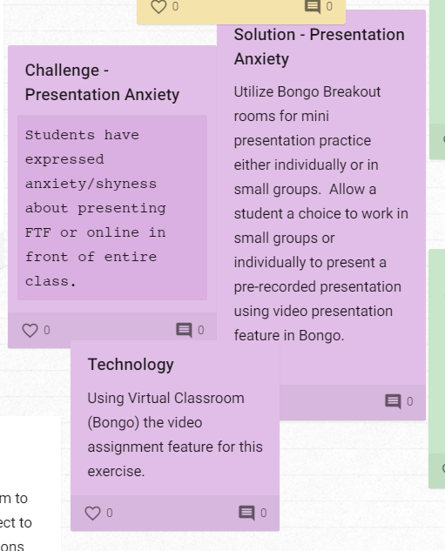n online

