Empathy Map (Garnered from observations of the past 3 years for the Embedded Systems course)
Hear | Since I am unable to ‘listen in” to in class discussions I must rely on what verbal feedback is given to me by my students directly to me. What I ‘hear’ most often is the dissatisfaction of the workload for the program. I do hear lots of: “ I really learned a lot in your course’ but there were lots of complaints about lack of hand holding in my fourth semester courses. They were very uncomfortable with self directed learning  I could understand this to a degree. Due to my disability I learned at a young age that I must supplement my iI remember how hard it was to discipline myself to be self-directed by focusing on achieving one goal at a time and how easy it was to be distrated by many other things. For things that interested me it was effortless to stay focused but to study things that were really necessary but did not hold that intense interest were rather difficult in terms of staying the course and seeing the study of materials to a mastery of the topic.
See | I saw a great mix up of responses from my students...a handful were always on top of things and achieving the desired outputs. There were also a tiny few who either did not come to class and/or did not hand in anything. The vast majority started out at the beginning of the term by just doing enough work to get median marks since they really struggled with the requirements to do research and come up with solutions on their own. About the middle of the term this large group of students began to be influenced by the go-getters and started to get the idea of what was required. As a result of a late start their marks ranged from the high 60s to 80s.  I was constantly talking individuallly to each student in the lab setting to get ideas on how they felt as they worked through the course materials. Many showed that they needed more guidance due to time constraints. Some simply were not aware of the connection between previous course materials and the present course they were undertaking.
Think | Building on the previous cell, I could see the vast majority had a “non-contiuum” mindset coming into the course. They had completely forgotten important information from prerequisite courses and hence were not able to apply previously learned knowledge easily or to be creative thinkers. They were able to connect the dots only when prompted with questions and often were surprised at how applicable the information from previous courses were. They did not think critically. They had to be led by the hand intially then as time went on became less fearful of forming ideas and opinions on their own.
Do | A number of students would NOT ask questions as advised but turned to complaining about what they thought was asked of them and many were so wrong in their assumptions which led to poor marks for poor performances. Another group of students who were doing well and asking questions tried to step in to help those who were not and the class becaome polarized at the start of the semester. As time went on though the students all came to the same point of understanding the need to ask questions and not assume anything. As time went on, it was noted that the students who initially complained and grumbled began to work with those who achieved successes and learned from these students.
Feel | The students demonstrated a range of feelings. Again the group who were doing well and participating felt a sense of achievment while others initially felt frustration and anger. A very small number felt totally lost; caught between the two polarized groups. That polarization did disipate about mid-way through the course; at the end, almost everyone achieved success on different levels. Only a couple of students who did not come to class or do the work failed to achieve any success.
Gather
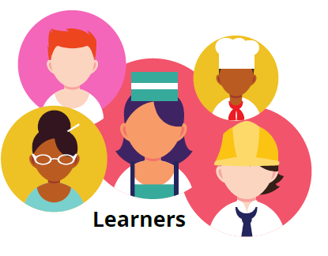

Key Strengths
They had a good attitude overall and were honest in admitting to shortcomings like the error of assuming things or in terms of gaps of knowledge or lack of time management skills.
Key Challenges
They had to learn quickly to switch gears from being spoon-fed in the first year to becoming independent learners and thinkers. They had substantial difficulty with time management and procrastination.

