Empathy Map
*Please make your own copy of this, using the …*
Gather information about your learners. Consider what they think, feel, say, do, see and hear in the classroom. What do they have difficulty understanding or doing in your class? What are their collective strengths and pain points?
Hear | Students hear the professor explaining new ideas, concepts.
See | Students see the professor demonstrating practially the ways in which to apply the theory and the proper way to perform a given task.
Think | Students tend to think more towards completing short term goals such as assignments or preparing for exams, but often forget the underlying basics of the concepts and have a hard time extending their learning to new situations.
Do | Students have difficulty in performing the tasks taught in class with the required level of detail and purpose.
Feel | Students feel frustrated when they receive their marks and have follow-up questions about why they did so poorly (eventhough, feedback and rubric scores are provided).
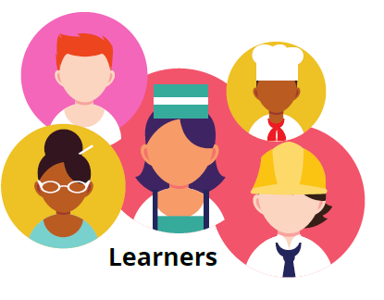

Key Strengths
- They all have access to asynchronous material (such as videos of the classes / lectures / labs, etc…) that they can refer to later or at their convenience.
- They have a variety of sources (such as videos, slides, collaboration tools, etc…) with which to learn and absorb the material
Key Challenges
- Differing infrastructure (especially in remote teaching scenarios) between students (not all may have high-speed internet for example or that they must share such resources with others in the same residence).
- Lack of support for students when they encounter technical issues

