Empathy Map
Gather information about your learners. Consider what they think, feel, say, do, see and hear in the classroom. What do they have difficulty understanding or doing in your class? What are their collective strengths and pain points?
Hear
See
Think
Do | Use more interactive learning inspite the fact the course I am teaching is a capstone project course
Feel
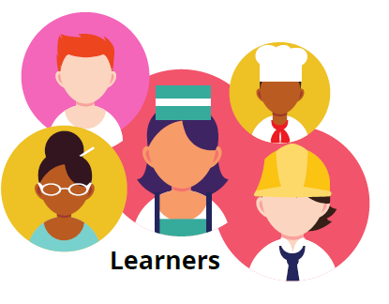

Key Strengths
Key Challenges

