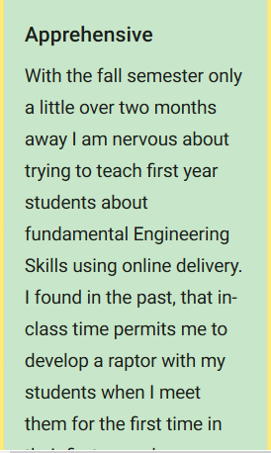
Image from Padlet

The post as text:
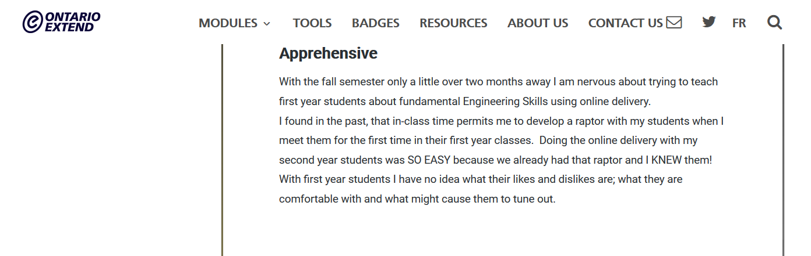
In this posting I anticipated the arrival of brand new students in the fall and felt at a loss of how to apply any online exercises since I have no idea as to what attitudes and aptitudes the incoming first year students will have.
Having the variety of resources and information to fall back on helps but, just as we learned in the DESIGN THINKING exercise, I feel that I face a HUGE unknown. Using the techniques presented in the Ontario Extend exercises DO help. I look forward to using these exercises to create a mindset of adventure and not fear of the unknown.

