This document uses the following reference link for my SECTIONS Worksheet
https://wiki.ubc.ca/images/1/19/SECTIONS_Framework.pdf.
In this framework there are four parts:
- Define
- Assess
- Implement
- Refine
Since I am not currently teaching, I can only respond based upon my recent experience with my a class held in the Winter of 2020, named Embedded Systems.
The students in this class are second year (fourth semester) students in a three-year program. The expectation coming into this course is that they have sufficient skills and knowledge to feel comfortable working in a fairly self-directed and fast paced course.
This core course is pre-requisite to their senior level courses. It is essential that there be rapport between the faculty and the students since the role of the faculty is a SCRUM master in an AGILE Project management environment.
The primary objective is to use the tool of choice to meet the challenge of maintaining an effective rapport with the students and to create a community of independent learners.
The tool I have chosen is an O365/TEAMS Channel to provide a venue (aka an online meeting place) for discussion which will be named: Online Café!
1. Define:
I really want my students to learn to feel comfortable when asking questions, making comments, having discussions, connecting to each other and connecting to myself.
I think I could be more effective in encouraging student participation and engagement by having a good rapport with the whole class. I believe that if I create a place where students could go to discuss topics related to the course materials with each other and to also ensure that students have a safe place to ask me questions/get answers from myself and support from their peers.
The learning activity that I have chosen to address these objective is the Engineering Skills Power Supply Project.
The technology I am thinking of using to support this learning activity is the TEAMS channel. I would open a channel as an online Café.
2. Assess:
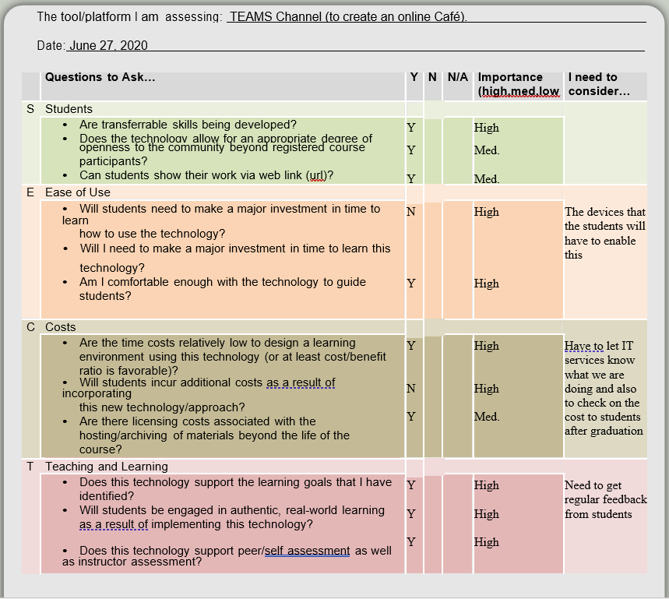
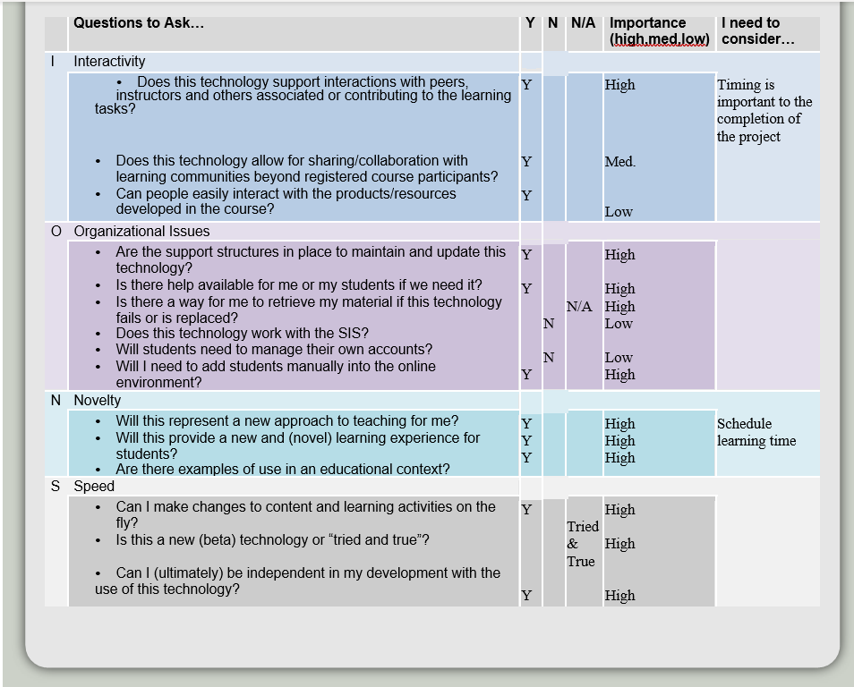

3. and 4. :Implement and Refine: Note: I cannot really comment on these two sections since I will not be able to properly try out the tool on real students so I am responding to the Implement portion based upon my own experience with students from the past few years.
When the tool has been implemented I will be able to join in the café and observe the students behaviour. What I am looking for is the development of a positive community for learning.
I anticipate that the tool will promote positive learning since a supportive community has been proven to do just that in numerous studies! Students are very comfortable communicating over online media and can feel less intimidated when posing online questions and making comments online than they would in a classroom. Posing questions and making comments about subject matter can lead to clarification of many a topic in a course and thus can lead to a more engaged student.
Using a TEAMS channel named Online Café has the potential in my opinion, to create a non-threatening discussion forum for the students by association since Cafés are generally known as places where people gather to enjoy talking over a cup of coffee or tea. This enables learning because student would be able to share their own unique understanding with others; learning from each other as well as supporting and forming collective agreements about subject understanding.
On the other hand, a TEAMS channel named Online Café may present a barrier to the learning process for those students who may have negative connotations about Cafés. It also has no benefit to those students who are completely unmotivated and need a high degree of structure in order to learn.
Since I have no classes over this period of time I cannot comment on students’ feedback about using this tool and can only conjecture that some will like it and some will not.
As the saying goes: „You can please some of the people all of the time, you can please all of the people some of the time, but you can’t please all of the people all of the time”.“ (
Zdroj: https://citaty.net/citaty/1342354-john-lydgate-you-can-please-some-of-the-people-all-of-the-time/)

