Creation as Curation – Vasudevan Padmanabhan – Padlet Screenshot
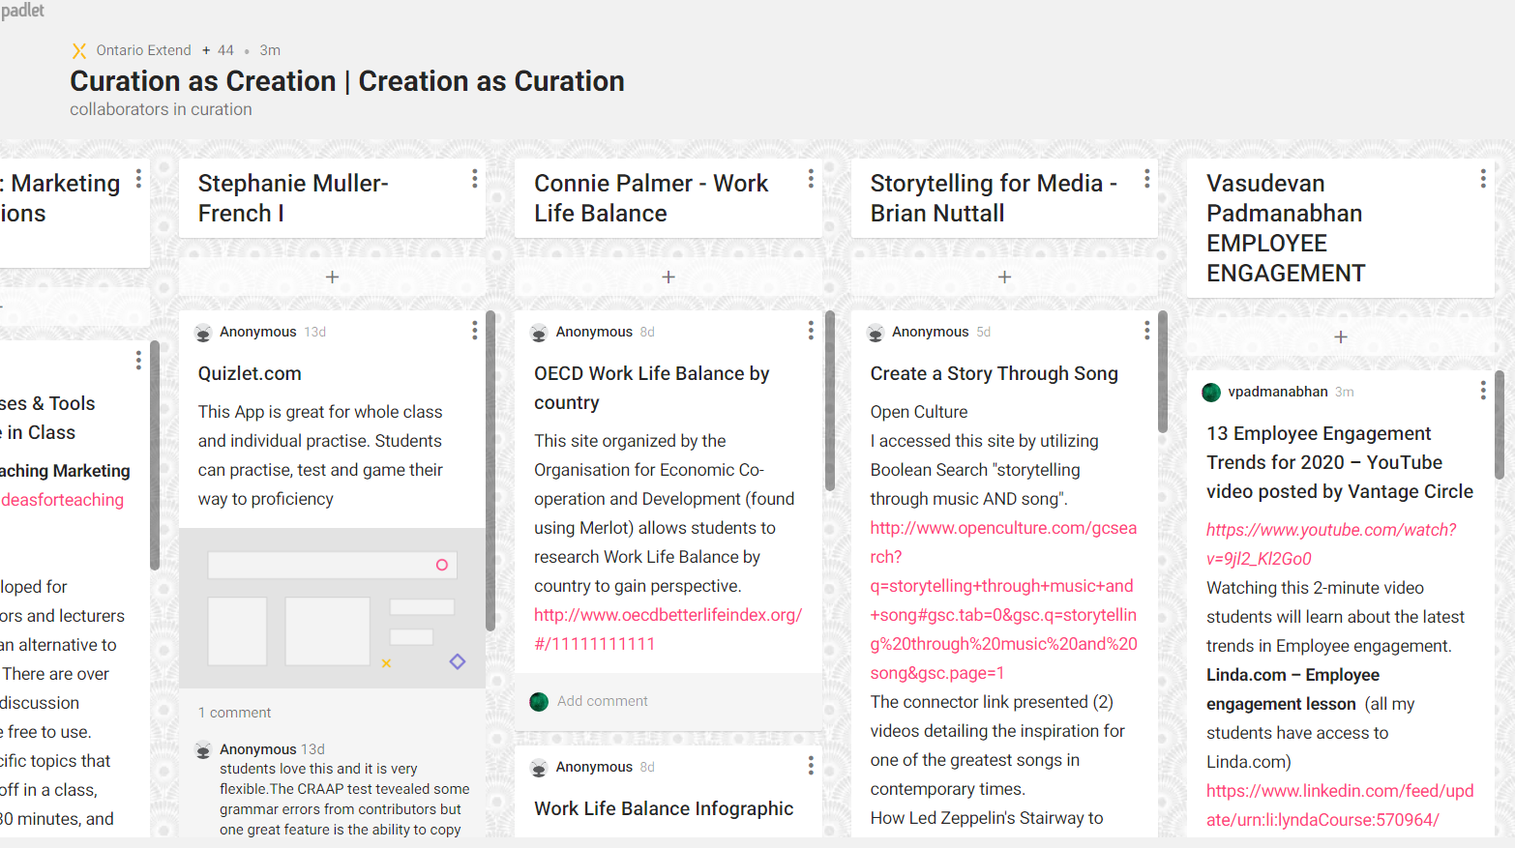
Padlet in word format
Vasudevan Padmanabhan
EMPLOYEE ENGAGEMENT
13 Employee Engagement Trends for 2020 – YouTube video posted by Vantage Circle
https://www.youtube.com/watch?v=9jl2_Kl2Go0
Watching this 2-minute video students will learn about the latest trends in Employee engagement.
Linda.com – Employee engagement lesson (all my students have access to Linda.com) https://www.linkedin.com/feed/update/urn:li:lyndaCourse:570964/
This is a video lesson which is split into topics. Each of these topics are covered in 2 to 3 minutes short videos with CC. Students can also listen to these videos while doing passive activities like driving – the audio is very clear and is not dependent on visuals.
Slide share posted by School of Management Studies(NIT Calicut)
https://pt.slideshare.net/NITCALICUT_SOMS/employee-engagement-15981246/9
In 20 slides the subject is covered well. Slides have good visual which will help learning

Employee Engagement in Context -By M. Gatenby, Chris Rees, E. Soane and K. Truss
This is a very good research paper with 4 case studies. Research will open the vision of students and they can learn how to implement engagement concepts
https://core.ac.uk/display/28884198?recSetID=

The free open course Employee engagement - OpenLearn - Open University - BB845_1
https://www.merlot.org/merlot/viewMaterial.htm?id=773403416
This is a complete Free course from open university. Students can use this OER as reference document

