Empathy Map
*Please make your own copy of this, using the …*
Gather information about your learners. Consider what they think, feel, say, do, see and hear in the classroom. What do they have difficulty understanding or doing in your class? What are their collective strengths and pain points?
Hear | - Instructor summarising the instructions on in class assignment  - Asking them for any follow up questions
See | - Instructor explaining the assignment requirements/meaning in small groups (in class), or to those who asked supplementary questions on zoom.
Think | - “It’s too less time for assignment.”  - “My break out room participants are not present”  - “Can I do group assignment individually as my usual partners aren’t present?”  - I am not sure what is required of me. I did not do these things in my country
Do | - Not present online even though the computer shows present.  - Don’t ask clarifying questions to help with assignment
Feel | - Stressed, pressured for time.  - Frustated as not have skill set
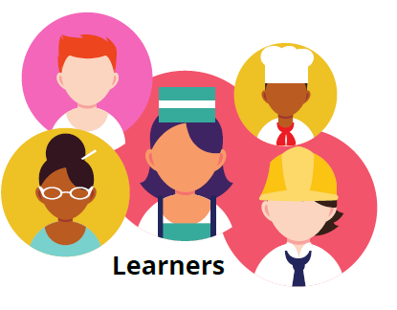
Challenge – not following instructions correctly or at all.
Key Strengths
- Want good grades
- Most have access to devices to enable online learning
Key Challenges
- Device might be too small (eg, smartphone) to have an enriched learning environment. Doing assignment on phone can be difficult
- Group work online can be more challenging as compared to classroom face to face group work

Define url:

