Empathy Map
*Click the … to download your own copy*
Gather information about your learners. Consider what they think, feel, say, do, see and hear in the classroom. What do they have difficulty understanding or doing in your class? What are their collective strengths and pain points?
Hear | - Students are concerned about the quality of the online interactions  - Overwhelmed by the volume of work being assigned  - A major concern is the lack of social interaction with their classmates  - Requests for extensions to deadlines
See | - An unwillingness to ask for help  - Unless called upon, many students do not attempt to participate in class  - A strong desire to be in groups with people they know  - Natural “leaders” emerge in the class – both online and in-class
Think | - Students are still trying to adjust to my classroom management style  - They are unsure of how to react to the collaborative environment being encouraged in the classorrom (Teacher-Student and Student-Student)  - They have many pressures that they have to manage – as they try to settle in Canada  - Some have no interest in the course material
Do | - Missed or late for class  - Doing the bare minimum  - Not volunteering to participate in class discussions  - Ask for help after exams and assessments  - Easier to share information via emails that in-person
Feel | - Overwhelmed and home-sick  - Fearful of technology  - That requesting to pass the course is an alternative to performance
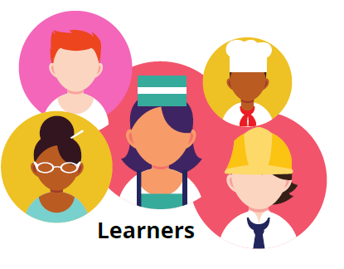

Key Strengths
- Very diverse in their education, professional and cultural backgrounds
- Generally, very articulate and smart
- Work experiences in various fields – with multi-national corporations
- Very adaptable and willing to work
Key Challenges
- Not fully grasping the concept of academic integrity
- Group think – especially at DTK with a homogenous community
- Not asking for help

