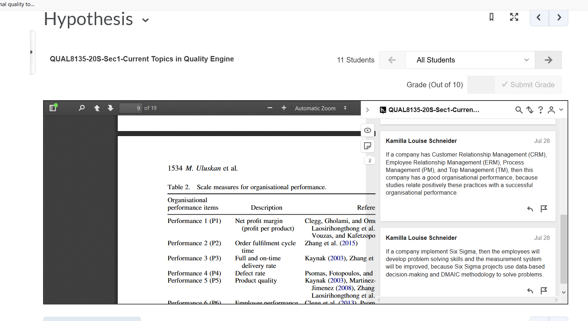
Figure 1 Example of Hypothesis
This was an activity that was completed online using the Hypothesis tool as in the scientific research students had to know how to formulate the hypothesis.
The only fit that I found was at MIT Education (Development of Hypothesis, Objective and Success Criteria (HOS) https://ocw.mit.edu/courses/aeronautics-and-astronautics/16-621-experimental-projects-i-spring-2003/lecture-notes/HOS21004_2.pdf

