Finding your fit – Vasudevan Padmanabhan
Subject : Employee participation
I tried using a long string like “ Employee AND Engagement OR Empowerment OR Involvement OR Advocacy”. Due my preference for simplicity I decided to keep it 2/3 words like as mapped below :
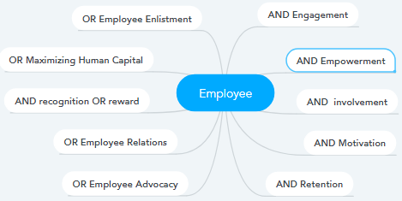
- I could search both libraries as well as the web
- In advanced I searched by material type, audience (specifically for higher education), material quality, technical format and mobile platform. I can also search by License
My search yielded may useful resources. I have selected and bookmarked them and plan to review in detail prior to fall delivery.

For this activity I have short listed the following material for use :

MERLOT – https://www.merlot.org/

I have selected the following OERs

- Slide share posted by School of Management Studies(NIT calicut)
https://pt.slideshare.net/NITCALICUT_SOMS/employee-engagement-15981246/9
In 20 slides the subject is covered well. Slides have good visual which will help learning

- The free open course Employee engagement - OpenLearn - Open University - BB845_1
https://www.merlot.org/merlot/viewMaterial.htm?id=773403416
This is a complete Free course from open university. Students can use this OER as reference document
Linkedin
- Linda.com – Employee engagement lesson (all my students have access to Linda.com)
https://www.linkedin.com/feed/update/urn:li:lyndaCourse:570964/
This is a video lesson which is split into topics. Each of these topics are covered in 2 to 3 minutes short videos with CC. Students can also listen to these videos while doing passive activities like driving – the audio is very clear and is not dependent on visuals.
- Linkedin Group - Employee Experience and Engagement
https://www.linkedin.com/groups/1787589/
I want students to join this Group in Linkedin. They can learn from Industry. This will also give them the context for the principles being taught in the class
- Article/s posted at Linkedin by Slideshare :
These PowerPoint slides are made professionally and are a quick way to learn Employee engagement
https://www.slideshare.net/NiojakHRMall/build-the-bottom-line-by-measuring-and-improving-employee-engagement

CORE – https://core.ac.uk
- Employee Engagement in Context -By M. Gatenby, Chris Rees, E. Soane and K. Truss
This is a very good research paper with 4 case studies. Research will open the vision of students and they can learn how to implement engagement concepts
https://core.ac.uk/display/28884198?recSetID= Employee Engagement

