It’s Like Driving a Car – The Interview Process

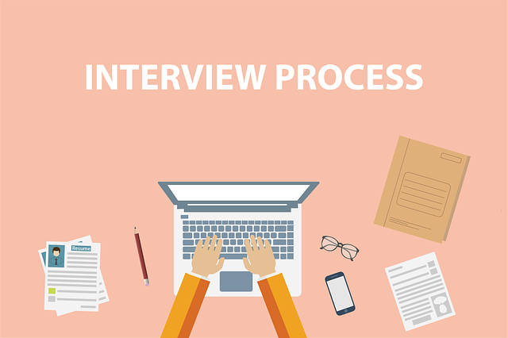

When instructing students on the importance of the interview process, it is important to breakdown the process into manageable steps including job descriptions, job advertisements, conducting interviews and selecting the right candidate.
I like to ask the students “what is the goal of the interview process?” It is important the students understand that the goal of every organization is to hire the best candidate for the job. Overall, if students can develop certain component skills, they will find the interview process to be just like driving a car.

COMPONENT SKILLS
Writing skills. Students must develop writing skills to produce job descriptions, job advertisements and interview questions.
Interview skills. It is important that students master the art of listening, asking questions, asking follow-up questions on the spot, and note taking.
Technical skills. Every student must become comfortable with identifying and using multiple media platforms to advertise their job ads.
Decision making skills. Perhaps the most challenging part of the interview process, narrowing down the field of candidates and selecting the best candidate for the job.

