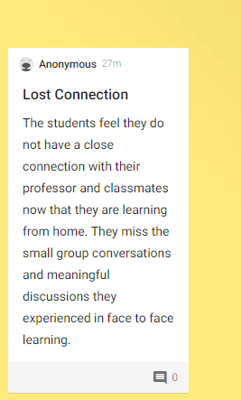
Learner Challenge 1 – Connie Palmer

