Virtual Field Trip
The Rights of a Worker/Occupational Health & Safety

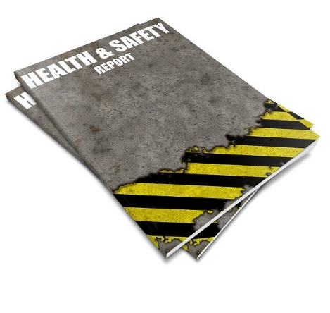
In this week’s lesson, let’s explore Occupational Health & Safety around the world.

Rights of a Worker
In Ontario, Canada a worker has basic rights in the workplace:
- The Right to Know
- The Right to Participate
- The Right to Refuse Unsafe Work

MapCrunch
Using https://www.mapcrunch.com/ you will be automatically transported to a unique address somewhere in the world.
Once you learn your unique address, research that location and discover what types of basic health & safety rights their workers have in the workplace.
In your submission, include not only the health & safety rights for this region, but comment on these rights as they compare to worker rights in Ontario, Canada.

