Empathy Map
Gather information about your learners. Consider what they think, feel, say, do, see and hear in the classroom. What do they have difficulty understanding or doing in your class? What are their collective strengths and pain points?
Hear | “we should have been shown this in first year”  “I didn’t know this existed”  “ I didn’t know we had access to this”
See | Teaching points being missed.  Lack of understanding in boolean logic.  Lack of understanding in the different types of information available and how to use it.
Think | Think they know a better, faster way. Think they already know how to search. Think they don’t know how to do it. Think it will be easy and straightfoward (until they try). Think that every tool is the same.
Do | Point of need is critical.
Feel | Scared they will make a mistake and worry about academic integrity incident. Feel it should progress in a linear way instead of being iterative. Feel there’s a “right answer”.
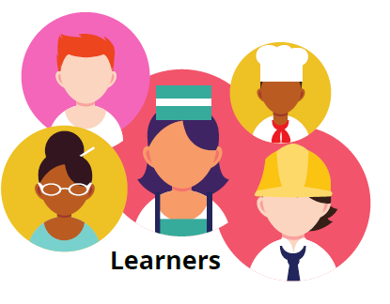

Key Strengths
Subject knowledge or interest in their subject.
Key Challenges
Prior knowledge and experience can not be assumed. Huge variability in individual strengths within a class. Some very comfortable, some are completely new to it.

