It’s Alive!
I chose a technology-enabled solution for my learning challenge mostly because everything has moved online and getting users to participate via online tech (Zoom) has been less successful than when in person. I find for even for myself, I’m more interested in participating when it’s an easy click on keyboard rather than speaking up. Since I am an instructor, I do participate in other ways but deep down, I prefer to just click and submit, no hesitation. Not everyone is “calling in” from a place where turning on the microphone or camera is desirable or possible. I’m also interested in finding a way to capture results so I can do pre- and post-assessment.
My process included empathizing with students in terms of meeting them where they are at and anticipating what they will actually need to be successful when doing research projects and assignments. I see the challenges they face when they act like they already know how to research, and hence don’t always participate, but then come back for individual help when they find they do need help. Research at post-secondary level is different from what some have done in the past so there is also a great deal of variability in skill set within one class.
I identified a tool, Mentimeter, that is free, super easy to use, visually appealing and one that I’ve seen work very successfully in other situations. It is pretty easy to learn how to use from the instructor point of view and the Institution I work in supports its use, somewhat. The plan is to integrate it into a synchronous learning situation where I teach and demonstrate and then ask for feedback via the polls and quizzes. To get a pre-assessment on student understanding or knowledge, I intend to use word clouds. The results from Mentimeter polls will help me guide the direction of my class as well since I can pivot the time I spend on concepts based on the results I see. Some examples of how I will use mentimete include the follow two slides. The fist is a word cloud where I can get user feedback on what they think of using Wikipedia. I’m very curious to see these results. The results then also help me decide what I need to focus on to convince students that Wikipedia can be a starting point but never an end point for post-secondary level work. My second slide will help determine if students understand Boolean logic. Saying you understand the difference between using AND or OR in a search strategy is often different than how students actually use the search terms. I hope to capture this discrepancy and show the students that they may need to think twice when choosing which term to use in their search strategy and how it impacts their results.
My two slides:
- Sample results included:
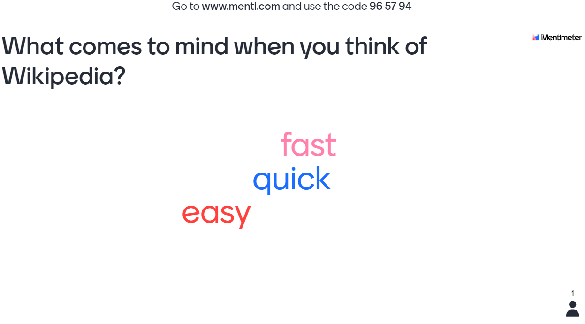
2.
