During this semester, the course that I taught was titled “Current Topics in Quality Engineering”. This topic required students to use the scientific research resources to complete the assignments.
I provided them with a list of scientific research in addition to our library at Conestoga College.
Since the resources list I gave them were: Google Scholar, Google Books, Worldwide Science etc. they do meet the CRAPP criteria:
Currency
- How recent is the information?
- How recently has the website been updated?
- Is it current enough for your topic?
Reliability
- What kind of information is included in the resource?
- Is content of the resource primarily opinion?
- Does the creator provide references or sources for data or quotations?
Authority
- Who is the creator or author?
- What are the credentials? Can you find any information about the author's background?
- Who is the published or sponsor?
- Are they reputable?
- What is the publisher's interest (if any) in this information?
- Are there advertisements on the website? If so, are they cleared marked?
Purpose/Point of View
- Is this fact or opinion? Do the author list sources or cite references?
- Is it biased? Does the author seem to be trying to push an agenda or side?

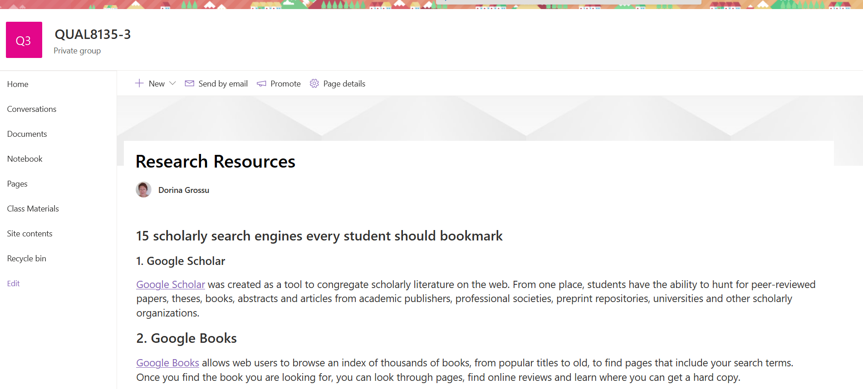

Dorina Grossu
dgrossu@conestogac.on.ca

