Tina Kolodzey’s Consider This Activity
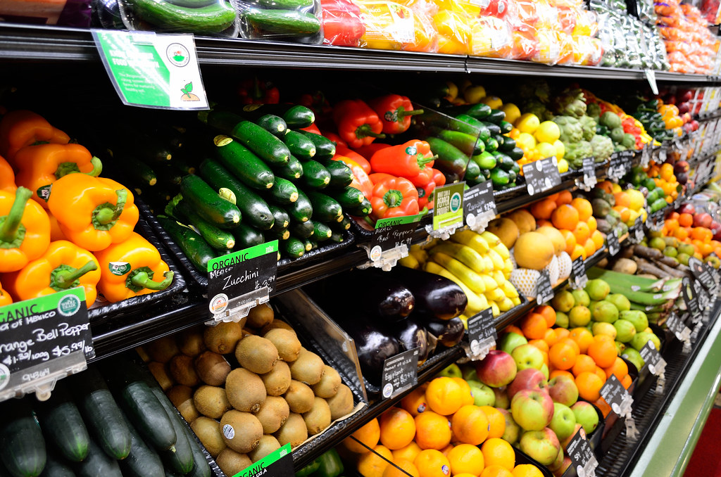
"Organic Vegetables" by Open Grid Scheduler / Grid Engine is marked with CC0 1.0

An activity that I might do with my students is shopping at a grocery store. I chose this picture from CC Search. Grocery store pictures are actually very easy to find using unsplash, flickr and CC Search, and even google. I love using CC Search because it gives me the copywrite information, and all I have to do is copy and paste it under the picture. That way, I do not have to worry about having the wrong information.
In LINC, we use a lot of pictures, and sometimes it is just easier to go and get my camera and take pictures. However, sometimes I cannot. Finding pictures gets harder when I want to talk about Justin Trudeau handing coats out to refugees at the Toronto Airport. When I searched for that, I found nothing! In that case, I get creative. I try individual photos – Justin Trudeau, Airport, refugees and coats, or I just choose one picture to emphasize one part paragraph.

