Karin Carter Kcarter1@conestogac.on.ca
Teacher for Learning Module

Metaphor Activity
My metaphor for teaching and learning is as follows:
“If you want a love message to be heard, it has to be sent out. To keep a lamp burning, we have to keep putting oil in it.” Mother Teresa

The picture that represents this metaphor to me is a mother feeding its young. Without food, the babies will die.

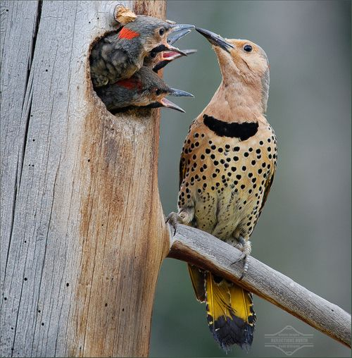

This image represents my approach to teaching because like a mother feeding her young, as a teacher I am all about teaching life skills, and positioning concepts that I am teaching to help them attain the life goals. Effective communication and persuasive presentation skills are core skills necessary in every facet of their lives: personal lives, relationships, work environment and attaining their goals. If am here to help them do that.

