Metaphor activity – Vasudevan Padmanabhan
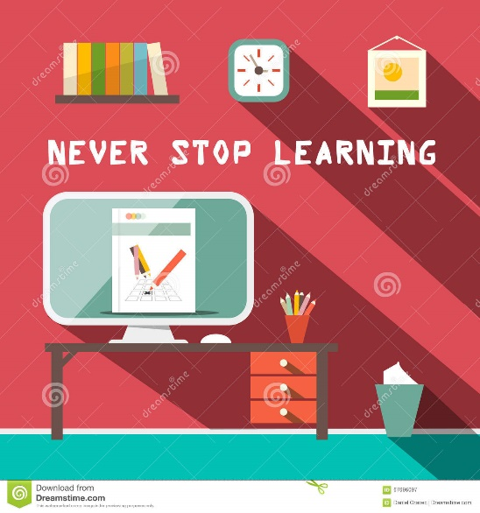
I am teacher because of the following core values:
- One must invest in learning/education through out their life. Never stop learning.
- I joined teaching to learn. I believe to confirm your learning you have to teach it. Both students and teachers should be learners all the time.
- Learning is a natural instinct – all want to learn – all can be taught with right teaching process
- Through education students can advance their career
- I have deep respect for all – empathy and sympathy are very important
- Base decision on facts and data.
My aim as a teacher:
- I want to teach my students hands on skills. Skills which they can apply at their respective work. Marry theory with good practice. continuously improve Quality and productivity by applying the tools learned during the course.
- Meet and Exceed student expectations. Respond and support them with 100% commitment

