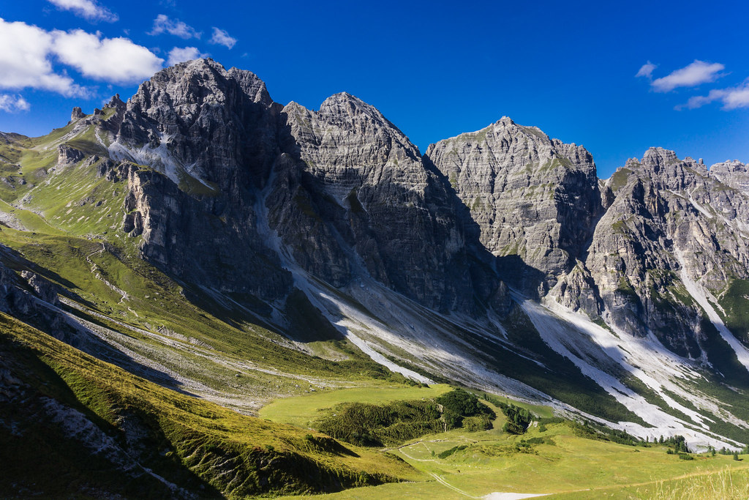

["mountain"](https://www.flickr.com/photos/75487768@N04/30973260633) by [barnyz](https://www.flickr.com/photos/75487768@N04" \t "_blank) is licensed under [CC BY-NC-ND 2.0](https://creativecommons.org/licenses/by-nc-nd/2.0/?ref=ccsearch&atype=rich)

My metaphor for teaching is climbing a mountain. At first, there are the foothills where you can just walk. Then, you may have to put a hand down every once in a while. Pretty soon, you are actively planning what your next step has to be.

You might start large rocks and good hand holds but you may encounter large flat walls needing different equipment and techniques. This may give way to ice which requires another set of equipment. Once you are finally at the top, you are left looking at the peak next door and how you could climb it…

One of the things most fascinating about teaching is no matter where you end up, there is always something else to learn. You have a chance to become the student to a certain degree again and again. A great experience came out of a student stating they did not understand what I had presented. That night, I built a model to illustrate the forces present within a structure that I brought to the class the next day. There is a simple joy that comes from seeing a student grasp a concept that was previously hidden, but the student showed me how to improve. If you look for the opportunity, it’s a cycle that never ends.