I have always considered that teaching is an art. A teacher, same as an artist, becomes even more creative when he/she is aware about the teaching methodology development process. An artist will put its soul and try the best during the creation process while allowing beauty to be born. Beauty exists whenever the creation of the new opportunities for students who are curious through their nature, will occur. Since each student expresses his/her feeling differently, I must be humble in my understanding.
I believe that students become successful if there is trust between us. I am curious through my nature as I can never stop learning, therefore, I invite the students into discussions through intellectual curiosity and dialogues. I am flexible and make nuance adjustments to the teaching presentation and include new areas of knowledge that have common interest among the present class of students.
“Teaching might even be the greatest of the arts since the medium is the human mind and spirit” John Steinbeck
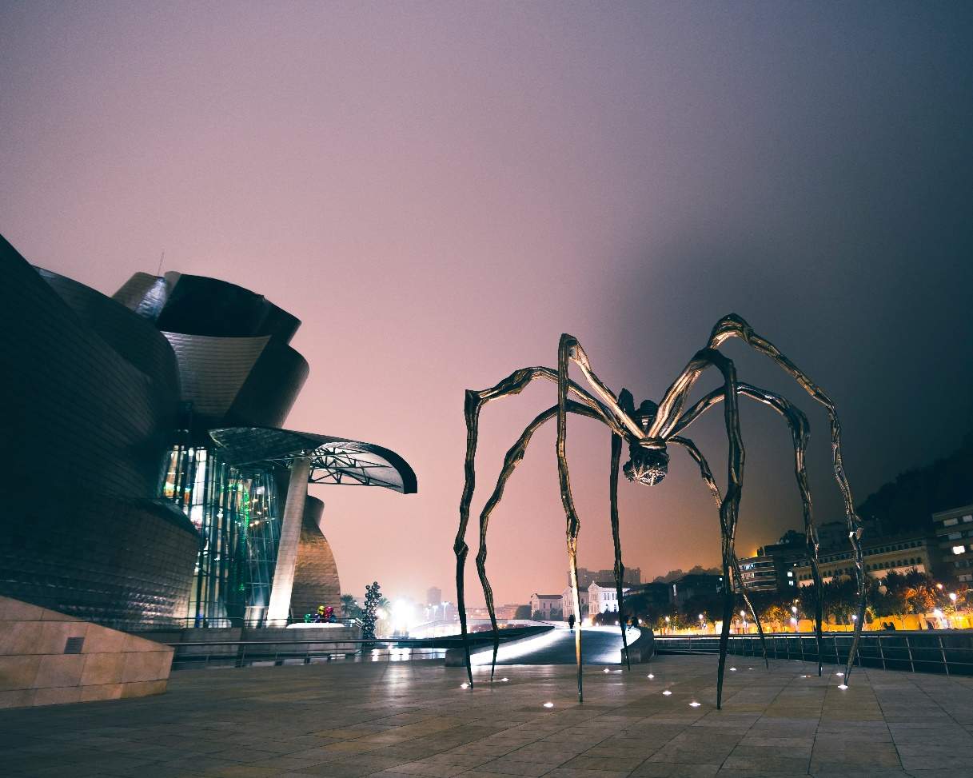
Photo by Sebastian Staines on Unsplash

Dorina Grossu
Professor
Conestoga College
dgrossu@conestogac.on.ca

