Excerpt from Patch 23 – (Un)prepared
“I believe my students are going to be alright. Some of them, no, many of them will be fabulous. We are going to make some discoveries this year. We’ll run into some surprises. We’ll reach an impasse or two and get beyond it. I’ll make some mistakes right before their very eyes. Some of the mistakes they’ll notice and others they won’t.
The year won’t be perfect. It will be full of learning and growth and doubt for me and my students. It will be entirely our year. We are prepared and we’re not. It’s on, ready or not.”
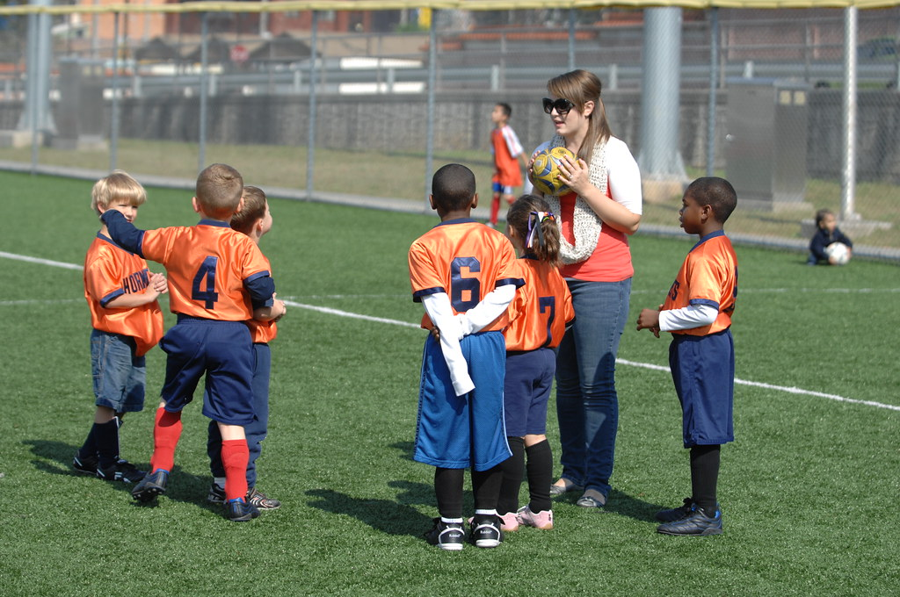
"Soccer - Army Youth Sports and Fitness - CYSS - Camp Humphreys, South Korea - 111001" by USAG-Humphreys is licensed under CC BY 2.0

This spoke to me in that I have just started my teaching journey 2 years ago. Every class brings new changes and challenges. The anxiety of trying to anticipate all possible things going wrong is both exhilarating and exhausting. Even courses that I have taught earlier reveal new opportunities for improvement.

I’m amazed at how I can learn from the entire spectrum of students from the range of skills and talents in the class. The students at the top of the class present something I haven’t considered before and the students who struggle show me how to present the material in a better way to help everyone learn.

It’s comforting for me to see the instructor who wrote this state their struggles with their insecurities even after all their time as an instructor. I have seen multiple times from people in the limelight who state they always feel insecure when they step on stage.

Why I chose this photo is because I found one of the greatest discoveries is how two sided the relationship is. I have taught and I have coached soccer. When a student succeeds, I’m over the moon. When they truly struggle and fail, it’s just as difficult for me. It’s a process of discovery and improvement that truly doesn’t end.

