PROMOTING DISAGREEMENT: HOW TO DEBATE AND NOT DIE
BY MATTHEW RYAN, FLEMING COLLEGE
I agree disagreement is essential for learning. However, we should teach student on how they should disagree. In the picture above the response is more directed at intimidating the other fox. I would encourage students to focus on what they disagree not on the person who is making the statement. Keep conscious of the two separate entities – “the person” and the “their words”. See picture below for clarity.
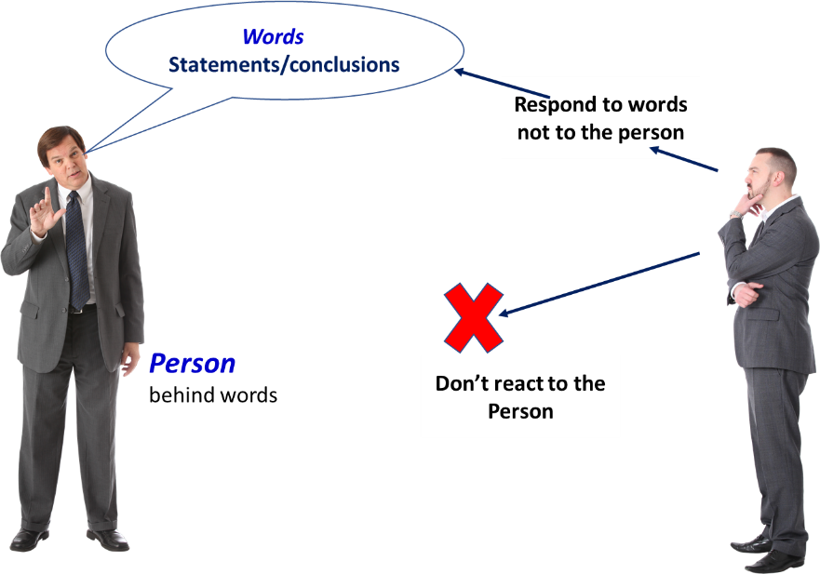

By focusing on the words(statements) we can initiate objective dialogue. Never use the word “You” or “Your”. You said this or your statement is incorrect. You don’t understand etc. Focus on the statement you have heard (not the person behind the statement) – review objectively and respond to the words.
I would also like my students to follow the below mapped process:
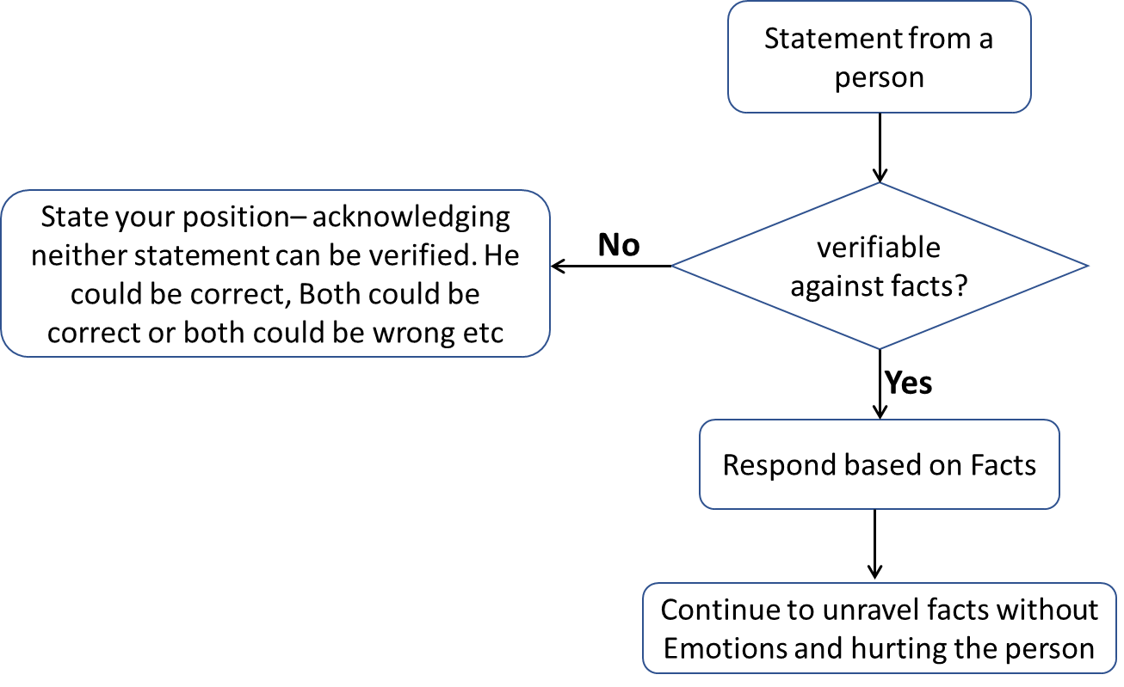
The existence of GOD or not cannot be verified against facts – both are non-verifiable statements. Fortunately, the statements and words related to what I teach can be verified against facts. So, I teach my students to keep facts in focus during their discussion – this leads to healthy conversations. Learning takes place without hurting anyone’s feelings.

