“Now, I am not wanting to argue that cohort-based learning is the be-all and end-all. I am glad that it is leavened by some choice and it is certainly good that, for example, general education classes provide a change of learning environment and focus, including an opportunity to shift gears and learn alongside students from other programs. We would also do well to consider where and how greater choice could be incorporated into our type of education. However, I don’t think we would be wise to assume that choice is automatically a greater good than some of the key ingredients of our type of education.”

Article written By Tony Tilly, President of Fleming College “A Patch about the Quilt of College Education”
https://openfacultypatchbook.org/college/the-overpatch-learning-in-a-cohort/
I always admired the connectivity between concepts and visual representations. As each student is unique so it is the learning path and opportunities that each drive on. There shall never be a constriction, but rather a larger variety of opportunities to chose from when learning. Within each class there can be more diverse knowledge as offered to students in smaller size courses that can be named “bits”. A quilt of knowledge is something that each student designs and it becomes his/her warmth in this comfortable era of accessible knowledge.
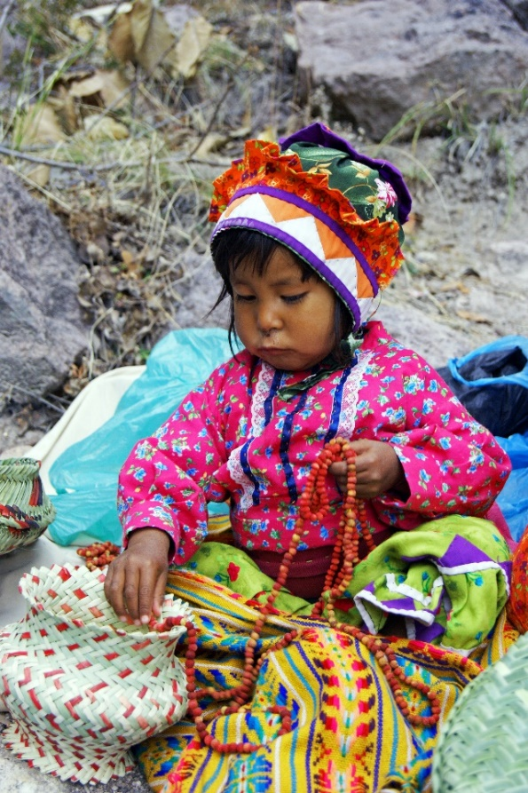
Figure 1 A young girl assembling beads Photo by Ruth Hazlewood on Unsplash
Dorina Grossu
Professor
Conestoga College
dgrossu@conestogac.on.ca

