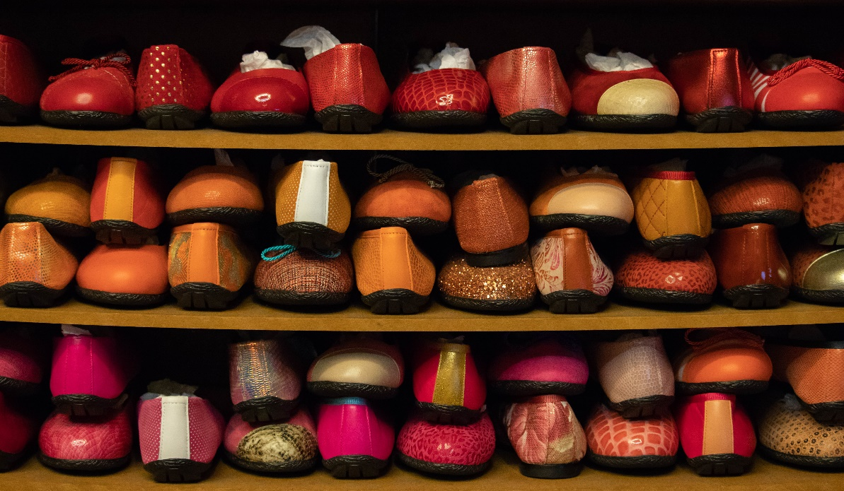

© Tomas Castelazo, [www.tomascastelazo.com](http://www.tomascastelazo.com/) / [Wikimedia Commons](https://commons.wikimedia.org/wiki/Main_Page)

Supply Schedule:

|  |  |
| --- | --- |
| **Price** | **Quantity Supplied (Qs)** |
| 0 | 0 |
| $5 | 3 |
| $10 | 8 |
| $15 | 15 |
| $20 | 24 |
| $25 | 34 |