It’s Live: Using Google Slides to Enhance Students’ Engagement
My initial Learner Challenge statement was defined very broadly:
“Students may find it more difficult to remain engaged, keep up with the course material, and manage multiple deadlines and projects in an online environment compared to face-to-face classes. This can be particularly challenging for first year students.
How can I help students to remain engaged without feeling overwhelmed with all the information provided on the course site”?
As I continued with completing the Technologist module and at the same time developing my online course, I focused more on keeping students engaged during the online synchronous sessions. The main technology I chose was Google slides to facilitate and improve students’ engagement while working in breakout rooms. It would allow them to document and share the ideas among students participating in each room, the entire class, and also students that are not attending the live session but have access to the slides. Please see an example of how I used Google slides for breakout room activities in Appendix A.
Then, I learned that Google slides is a very effective tool for incorporating other technologies in the session such as Mentimeter, Bongo Polls, and Quizlet:
- Mentimetre open-ended questions: I used Menti at the beginning of the class to receive input from students on a topic that can be referred to throughout the session. In this case, asking students about the goals they have defined for their project teams during a session that is focused on strategic planning (please see Appendix B). Menti results were included in the slides after the session.
- Bongo polls: I launched a Bongo poll closer to the end of the session to collect general feedback (please see Appendix C).
- Quizlet: Quizlet was used as a way to provide additional examples for a concept that I explained during the session. Quizlet allowed me to save time and avoid an overloaded slide while directing students to an engaging activity (please see Appendix D)

Appendix A: Using Google Slides for Breakout Room Activities
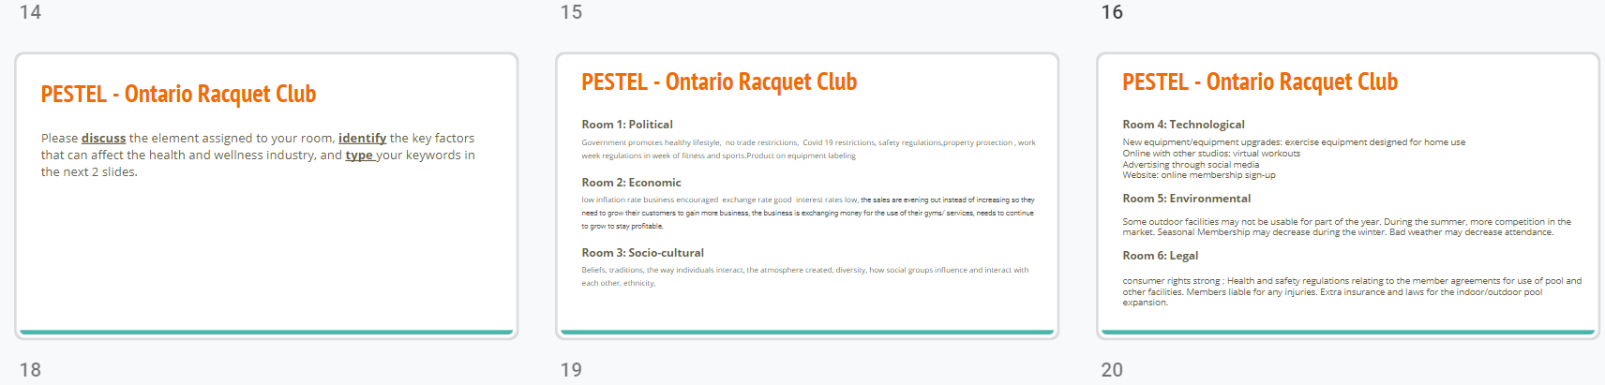

Appendix B: Mentimetre
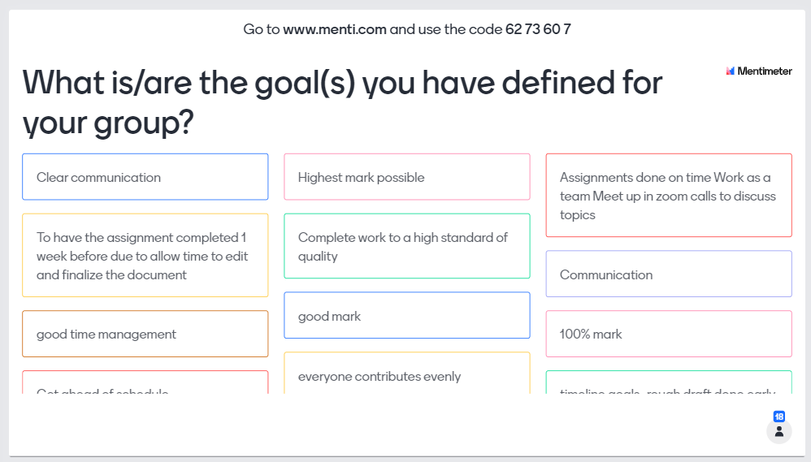

Appendix C: Bongo Poll Incorporated in Google Slides
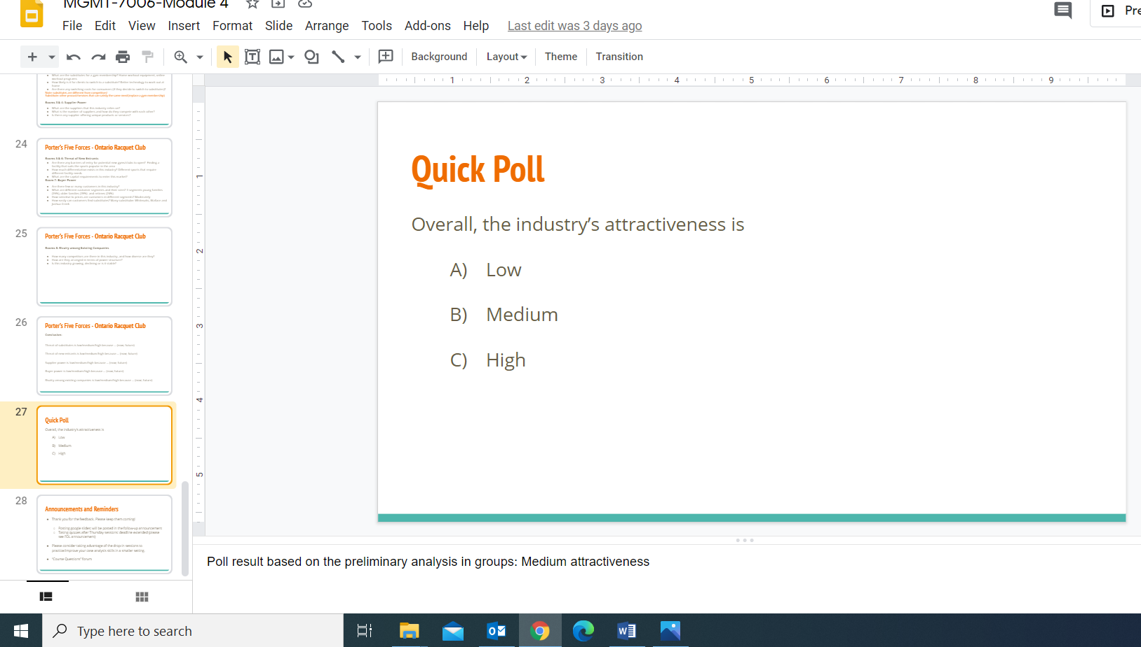
Appendix D: Quizlet Activity Incorporated in Google Slides
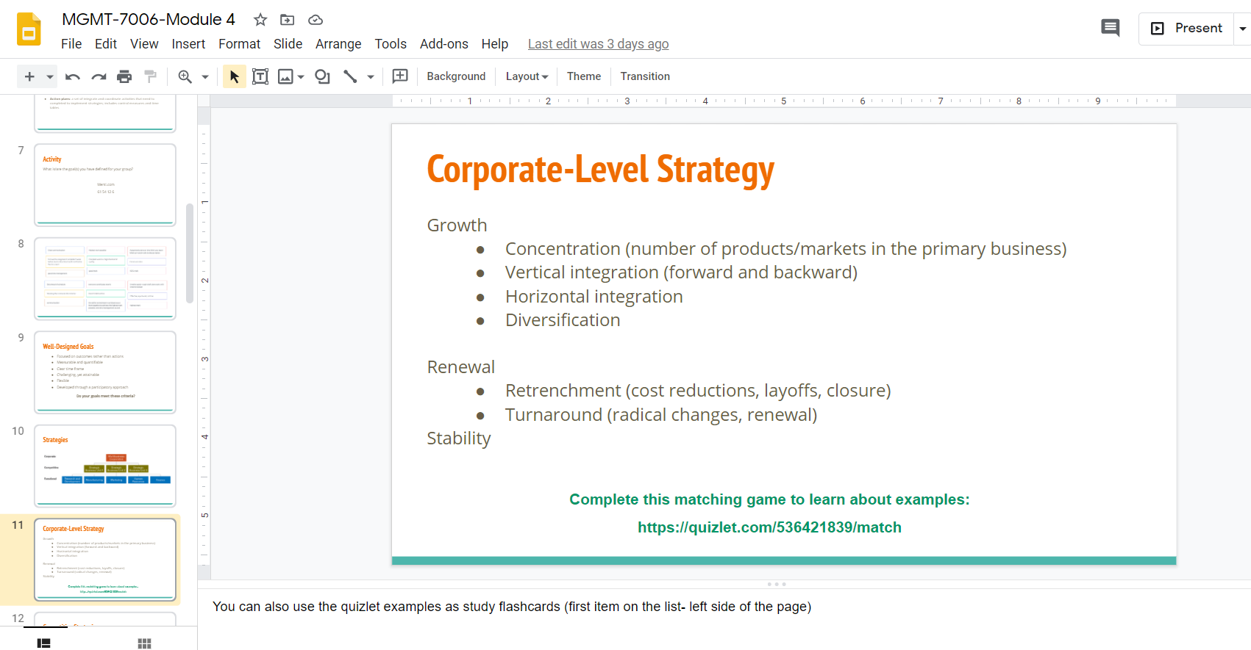

For the complete slide set please click on this link: https://docs.google.com/presentation/d/1OOouJaeJAz7FDLDcZ9brvA60lmykTiuVw5IAqgq9WXw/edit#slide=id.g9c32c4b080_0_17

