It’s Alive! (Elizabeth Tellez)
I learnt how to use the MS Teams channels; they work perfect for the activities I planned for my students. Students love them because they give them the opportunity to interact with each other during class time and they don’t have the pressure of talking to the whole class.
This is my group and the different channels:
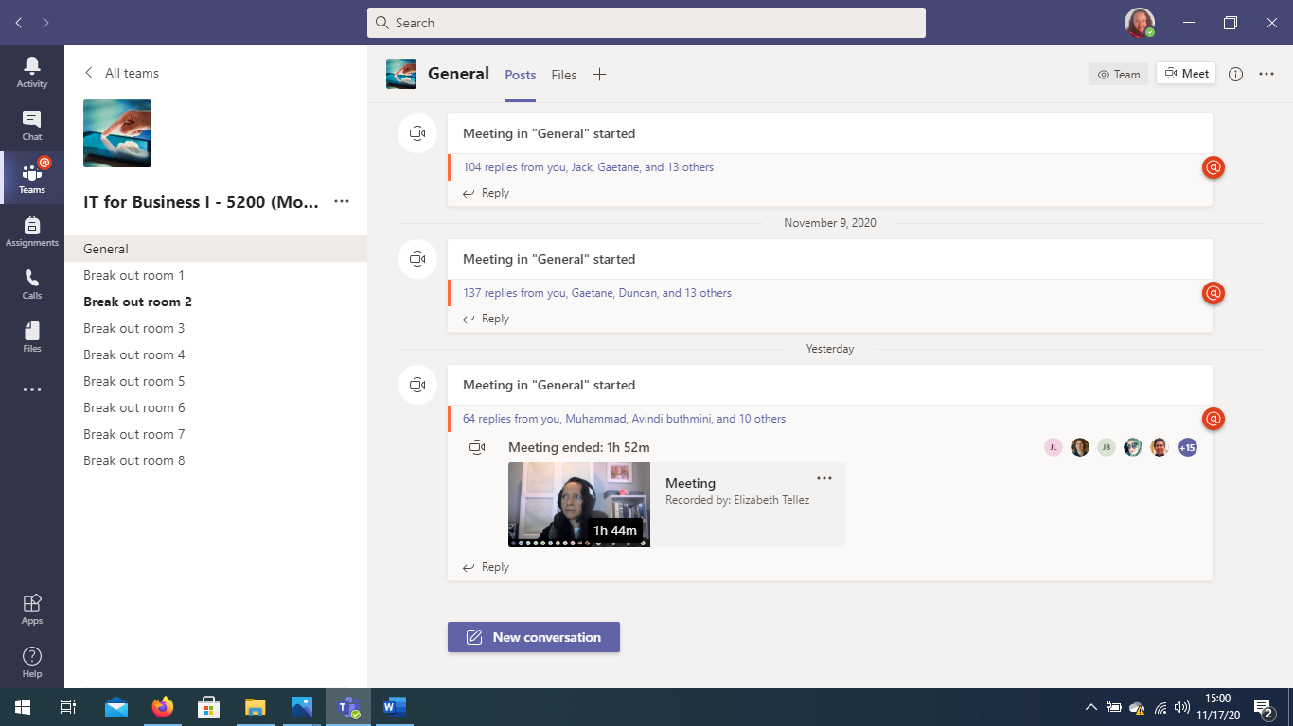
Using MS Teams, I also recorded a session with an IT Professional, he is an Associate Director at AT&T, in the Broadband and Video area. He started as a developer, and he emphasized the importance of excellent business communication. It was a great interview and the students realized they need to practice their soft skills because they will need them at their job place.
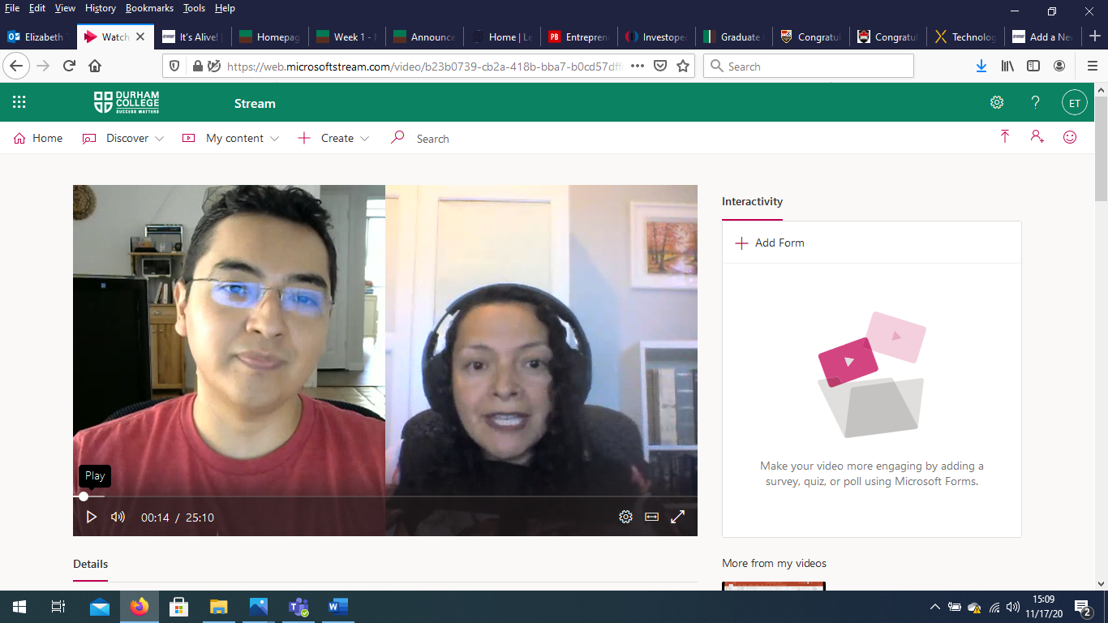
I really like MS Teams because it has different features that help with the online classroom, I can share videos as well, I can use the whiteboard, etc.

