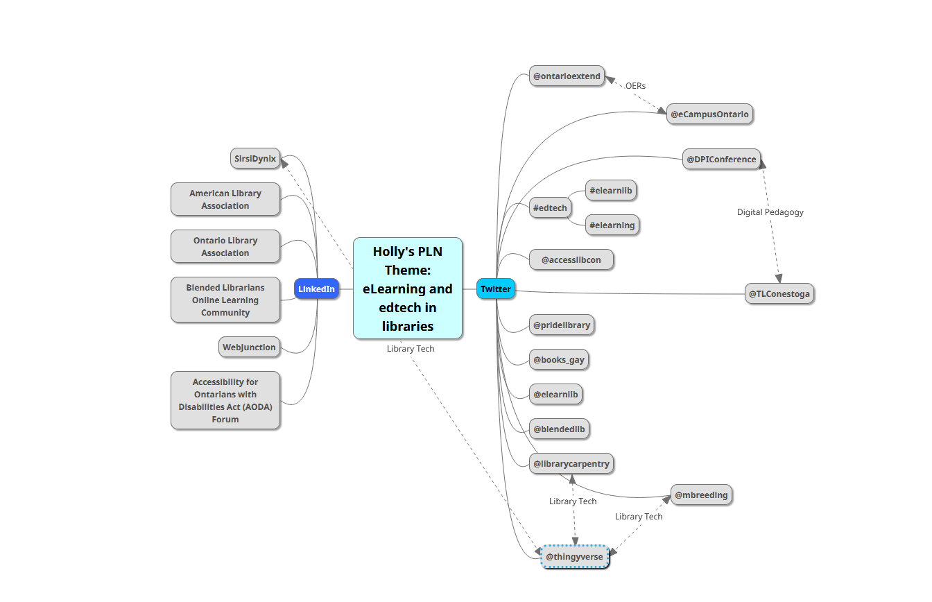

### Extend Activity: Mapping your PLN

### I consider myself relatively new in my position.

### Most of my connections are one-way, weak connections. They will grow and develop as I gain experience and confidence in my career.

### The elearnlib, OER, and diversity connections are more collaborative in nature, and I consider them stronger connections.

Diversity

Accessibility

Library Trends and Standards

Library Technology