Accuracy and precision are always get confused when we use these terms in Project Management.
Accuracy is the closeness of our answer to the true value whereas, precision is the closeness of our answers to each other.
For better explanation I have used dart board game. Darts strike on the board close to true value will be having high accuracy and close to each other will be having high precision.

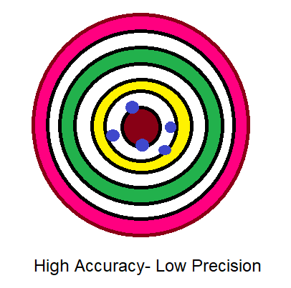 | 