A coach plans, schedules, motivates, guides and controls the individual or a team. He often set the expectations for the team. He uses his experience to improve the level of the team and all the individual players that comprises the team.
The same way in my class I always motivate them. When we discuss a case study in the class, I ask them to think, if you are the Project Manager for the scenario what you will do? Students will give their perspective as a Project Manager. It enhances their confidence level; Learn how to perform in a team in order to achieve the goal.
I share my experiences, throughout the knowledge areas, how to stick with plan, how to develop schedule, how to apply corrective measures if deviates from the plan, how to monitor & control it. I often giving real time project examples and the explanation gives students better idea to link with real time with the explanation in the book. They visualize the various hats a Project Manager has to wear in real time projects.
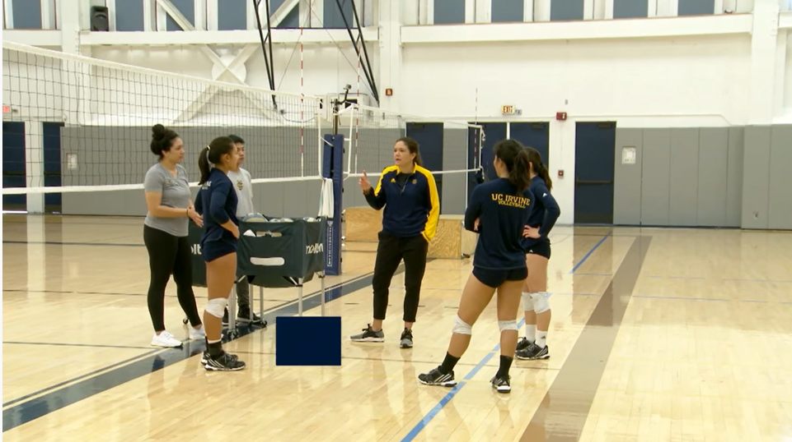

Inside Volleyball Practice - Coach Ashlie Hain

https://www.youtube.com/watch?app=desktop&v=ldEDX_JfCsc

