Consider this activity

The image I was searching for was to illustrate how copyright is often considered restrictive in how it is used to create course content.
I searched Creative Commons first by using “prison bars”. The results were well organized and easy to see license terms. Next I added in “OR restrictions” and this produced very few results. I then searched with only “restrictions” and the images retrieved were historical black and white, not what I was looking for.

Next I conducted the same search and search strategy in Flickr. In my first search with “prison bars” a lot of results were retrieved. I did have to then select my license terms, which I selected “All Creative Commons” in order to be provided with only CC images. The first group of results that appeared first represented people in a bar instead of prison bars that I had entered. The people in the images on the first results page were white, no diversity represented. When I added in “OR restrictions” the same results as the previous search appeared at the beginning. When I then searched with only “restrictions”, the results were not relevant.

The last place I searched was Unsplash. I completed the same search strategy. The first search with “prison bars” was easy to conduct and the results were relevant. The people included in the images did represent various ethnic communities so diverse and inclusive. When I added in “OR restrictions” it increased the number of results and again the images did provide diversity of people represented. For the search with “restrictions” it retrieved a lot of COVID-19 images with people and protests, not what I was looking for.

Based on these searches, prison bars was the more successful search and the images I would include to illustrate the concept of restrictions associated with copyright are attached.

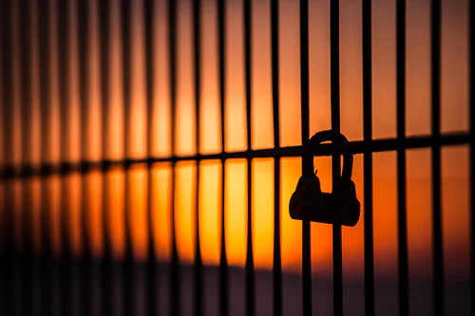
Image 1: Photo by Saad Chaudhry on Unsplash

Image 2: Photo by Weston MacKinnon on Unsplash

