Find your fit
Concept I selected OERs for: Evaluating resources

The OER repositories I reviewed to find these items were Open Library and OASIS.

The 4 I selected are:

https://openeducationalberta.ca/libraryskills200/chapter/evaluating-resources/
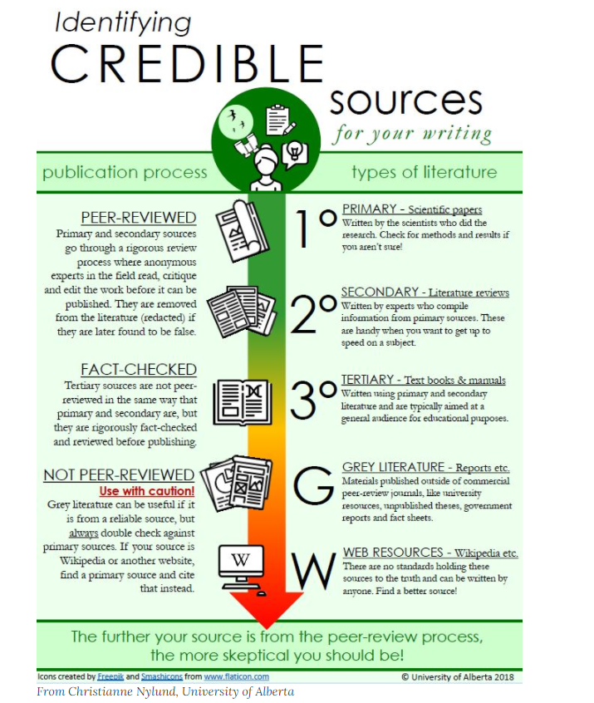

This is a great visual that explains the publication process and the different types of literature. This is an area that is often difficult to understand and this helps visualize it and provide brief information about each area.
This is my preferred one and if I had to pick only one to include, this would be it. The visual is well designed and clearly provides information that learners can refer too when reviewing sources.

https://openeducationalberta.ca/librarylabmanual/chapter/3-5-evaluating-sources/

Educational Psychology Library Lab Manual by Denis Lacroix is licensed under a Creative Commons Attribution-NonCommercial-ShareAlike 4.0 International License, except where otherwise noted.

Provides a video to explain the CRAAP model for how to evaluate sources
https://www2.library.ualberta.ca/tutorials/foundational/4-1-synthesizing-and-evaluating-information.mp4
The use of a short video is a different format to support learning.

From OASIS:

McHale, Christopher, "Evaluating Reliability in Resources [Library]" (2017). CUNY Academic Works.
https://academicworks.cuny.edu/lg_oers/13
An example of an assignment to have students evaluate information they find. I would adapt it to fit the audience of the learners.

Moran, Cristy. "Evaluating Internet Sources - Climate Change." CORA (Community of Online Research Assignments), 2017. https://www.projectcora.org/assignment/evaluating-internet-sources-climate-change.
Another example of an assignment that provides learners with the topic and the internet sources that they then apply the CRAAP theory to to determine whether or not they are credible. The topic is relevant and one that I often have learners searching. It also uses sources found online which is often where learners are looking for their research.

