Module 1 Teacher for Learning
Activity #5- Like Driving a Car
Early Childhood Education students have many skills that they utilize in the field of early learning. The College of ECE’s outline 6 standards of practice that should be followed when working with children and families. The first standard focuses on Caring and Responsive Relationships. This principle indicates that RECE’s should understand that strong, positive relationships contribute to healthy child development and are necessary for children’s well-being and learning. If I share this statement in class, all students would agree. However, if I asked them to define it or explain what a strong and positive relationship looks like, I would get a variety of answers. ECE students, like most people, have their own ideas of how to interact with children. This may come from their personal experiences or may come from what they have witnessed or have been told by others.
My role as an educator is to break that principle down into smaller segments so that students can gain a theoretical understanding of child development, how learning occurs, self-regulation, as well as health and well-being. We bring so much personal experience (beliefs/biases) to the classroom it can sometimes be challenging to change our understanding of these concepts.
In order to help facilitate this, we do a lot of observations and reflections. Sometimes as a personal reflection but whenever possible as a group so that we can challenge each other to think more critically about how it all fits together.

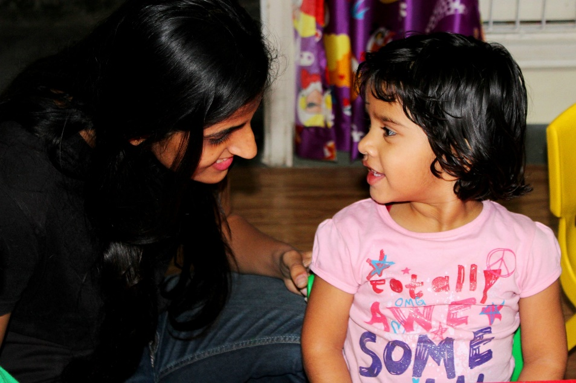
Image by Kevin Lopez from Pixabay

