Like Driving a Formula Car

In Excel one of the most challenging concepts to learn and to teach is formulas and functions. The difficulty is understanding the “syntax” or the way a formula is structured. However, this is exactly how I teach it. I break it down into smaller components so students can understand each part separately and then put it all together. If they understand each part that goes into a formula then generally, they can piece it together and get the whole correct, even if they don’t know the math behind it.
I start with the math basics, add, subtract, divide and multiple. Moving to order of operations and all the ways Excel understands math. Once student see the parts of calculations are pretty easy we move to the structure of formulas and functions.
I like to use the formula builder below to help:
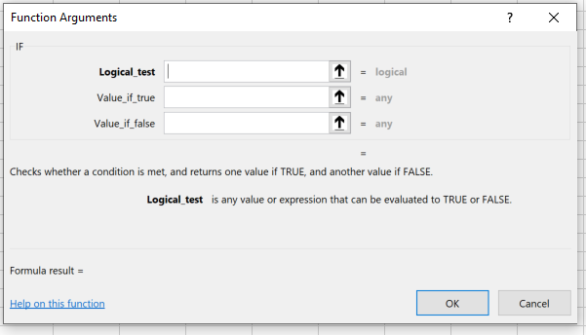
This tool helps move the student step by step and even let’s you know if the step or answer makes sense. It will show you if there is an error in your logic and a formula result on the bottom left.
Another process I like to try is laying out the structure and walking them through examples like this:
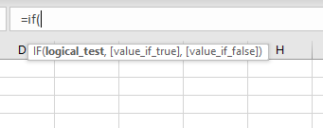
I’ll walk them through each part to build the formula and explain what and why goes into each, including the commas and brackets required.
If students comprehend each part and slow-down they will not forget a very important comma, bracket, $ to make a number absolute or anything other part of the steps to get a formula to work. It takes practice but this strategy works for me and my students.

