Misunderstood Concept-Pamela LeBrun What-If Analysis

In teaching Excel to business students, I often find that they get confused when we discuss What-if Analysis tools. What really is misunderstood is the concept of What-if in business and how using these tools can help look at future projections and budgets. I’ll start with the simplest tool in Excel called Goal Seek and use it to create business scenarios.
What I like to do is have students brainstorm businesses they’d like to start now or when they are done school. Sometimes I will use a scenario that a young child may have started like a Lemonade Stand. Once the students have a small business in mind then we can discuss using the tool in Excel to predict What-if our prices went up, what if our raw materials cost more or what if we want to reach a Net profit goal? I find the visualizing and using a small business analogy can help them relate why businesses may use the tool.
One example I’ve used is Pamela’s Apply Pie Company. I will discuss the raw materials like flour, butter, apples, cinnamon and so on and use simple numbers in the Goal Seek Excel to demonstrate. This activity helped extend my thinking in that I might also use images to really deepen the example for students who love visuals. Pictures of the ingredients and finished pies while discussing the tool could help make it more relatable. It would connect real prior knowledge with business concepts and tools in Excel.
Photo by Natallia Nagorniak on UnsplashPhoto by Benigno Hoyuela on Unsplash

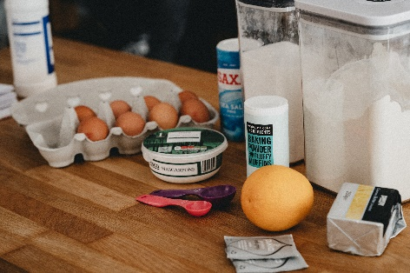Photo by Annie Spratt on UnsplashPhoto by Food Photographer David Fedulov on Unsplash

