Screenshot from Fanshawe Google Doc – Ontario Extend Scholar Module
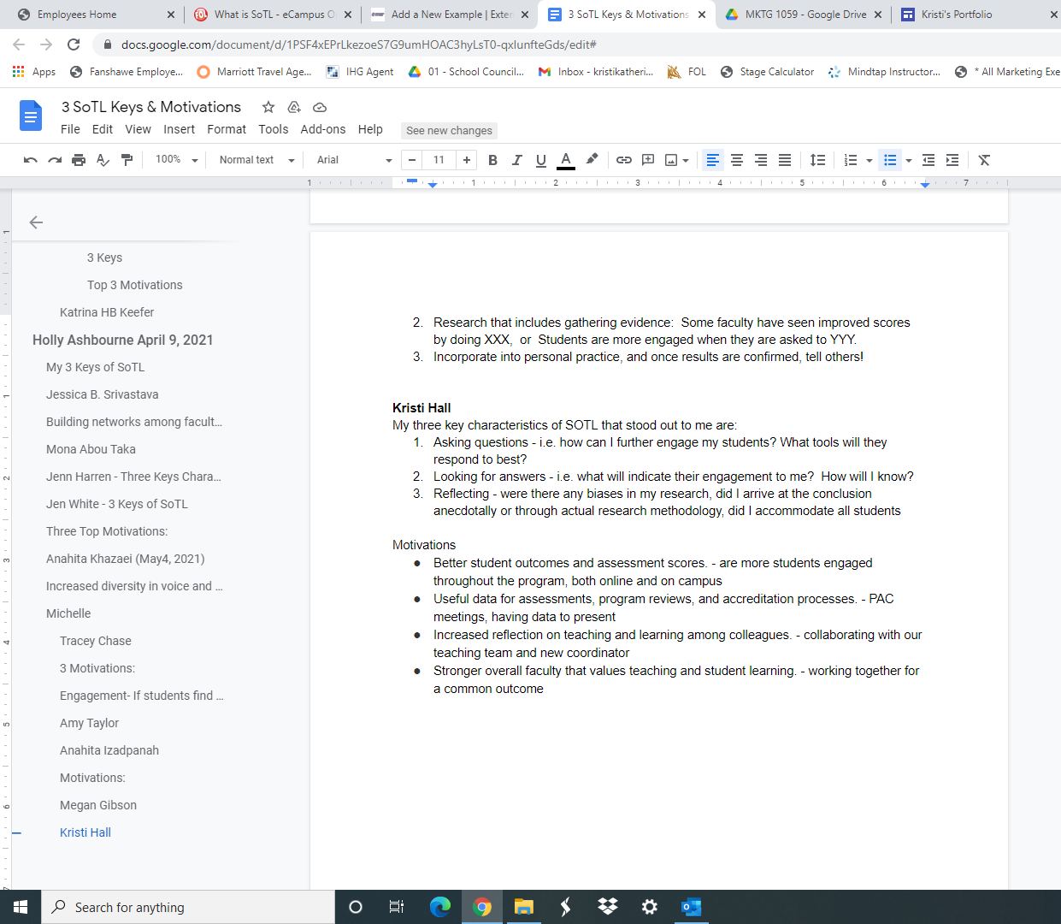

https://bank.ecampusontario.ca/response/three-keys-activity/.

