Teach4Learning

Platform Agnosticism

A misunderstood concept in Ed Tech— is that of “platform agnosticism”— the notation technologies can be separated from pedagogies. The tools we use speak volumes to what we value in learning.

The impact— for educators— is making decisions based mainly on what seems to be convenient rather than modelling approaches which align with their values as educators. This, in turn, can lead to students viewing their learning experience as a commodity to be consumed— and diminishes engagement and deeper learning.

If you see every tool as a hammer, every problem will look like a nail.

In terms of what better dealing with this problem— providing teachers with a wide range of tools and timely, scaffolded approaches to professional development is important. If teachers feel creative and empowered, then this will translate to better and more creative learning opportunities for their students.

In terms of technology choices, a more appropriate metaphor is using materials at hand to co-construct knowledge and experiences with learners. To use a term associated with constructionism, learning can be thought of as an act of bricolage—as per Seymour Papert, i.e., roughly “the art of tinkering or making do with materials at hand” (Lehmann-Haupt, 1993).

Lehmann-Haupt, C. (1993, July 22). Books of the times; learning better how to link up computers and education. New York Times.

https://archive.nytimes.com/www.nytimes.com/books/99/01/03/specials/papert-machine.html

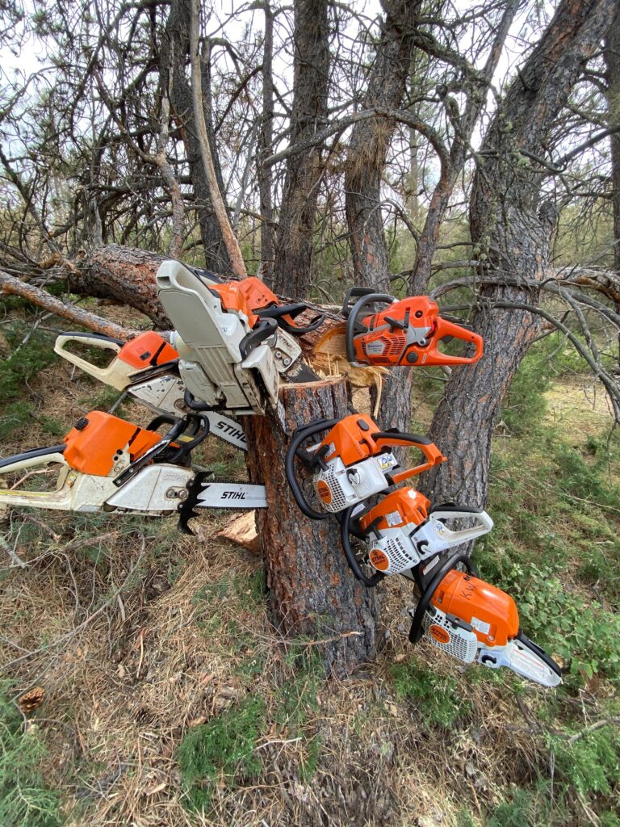

Photo by Greg Evans on Unsplash

