**Patch 21 – Just Listen**

But the simple fact of the matter is many of us hold our advanced degrees because of our unique passions or uncommon aptitudes. And when we land our teaching roles, when we take responsibility for the education of first- and second-year college students especially, our primary audience becomes students who never have shared those passions, and who have a completely different set of aptitudes than those that got us our graduate degree. **We have to adapt.**

*The above paragraph really resonated with me because that was me in my first year of teaching. I could not understand why the students just didn’t do it they way I told them. It is so easy that way. I soon realized it was easy for me as I was looking at it from my perspective not theirs. I had to realize that there is more than one right way to complete something, and students may approach it from a totally different point of view. We are not all wired the same way.*

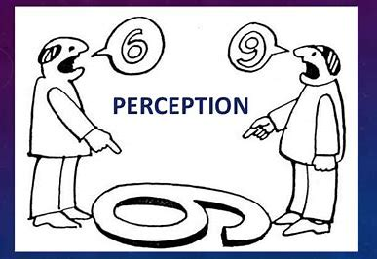

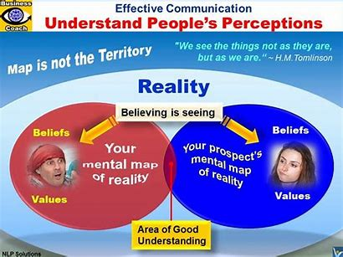

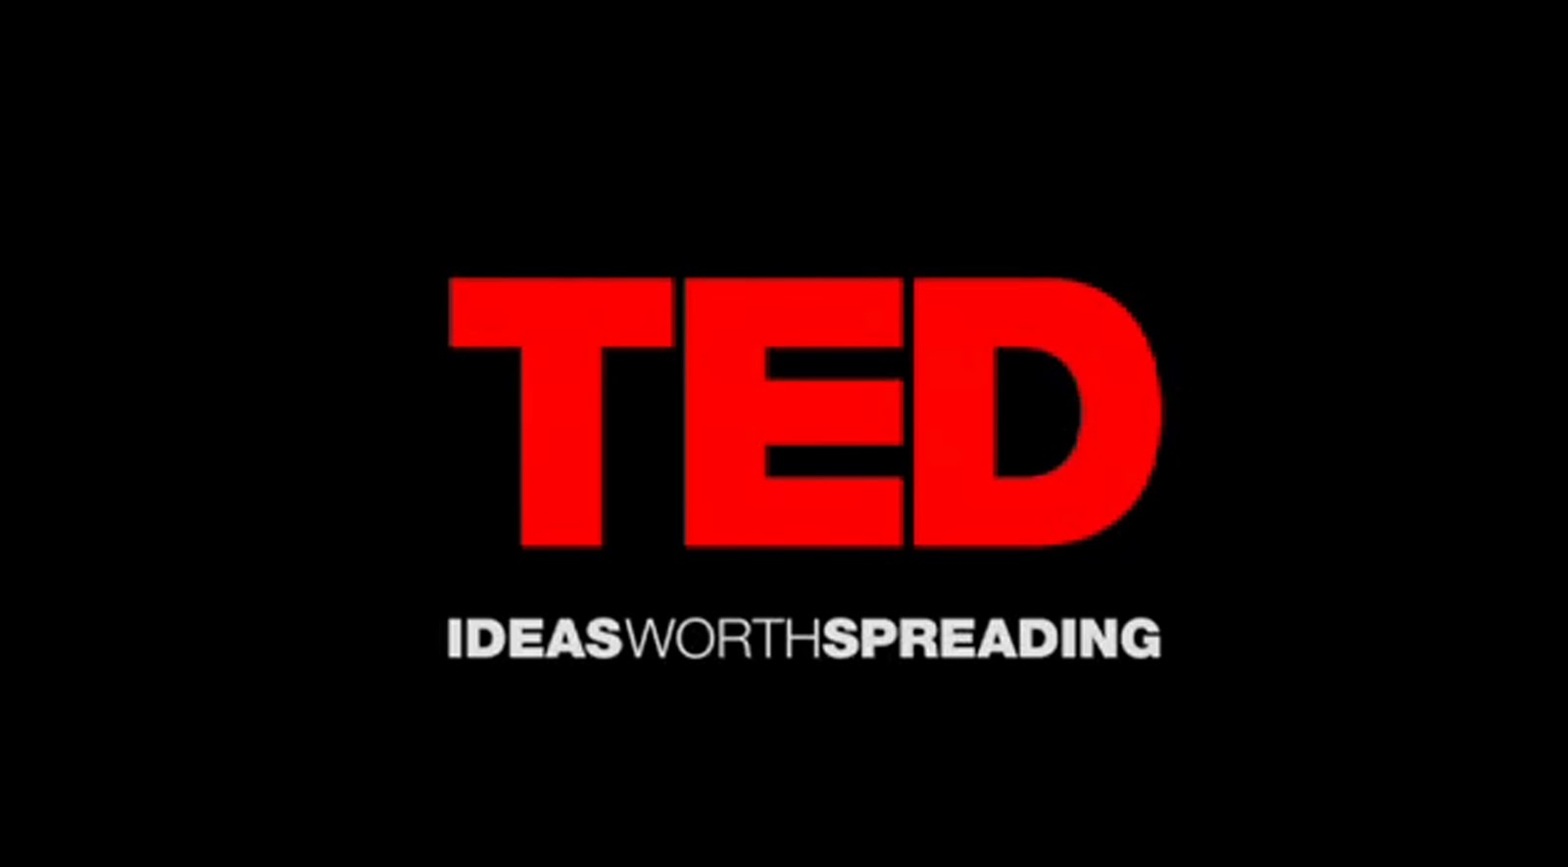

[Tony Salvador: The listening bias | TED Talk](https://www.ted.com/talks/tony_salvador_the_listening_bias)

[Tony Salvador: The listening bias | TED Talk](https://www.ted.com/talks/tony_salvador_the_listening_bias)

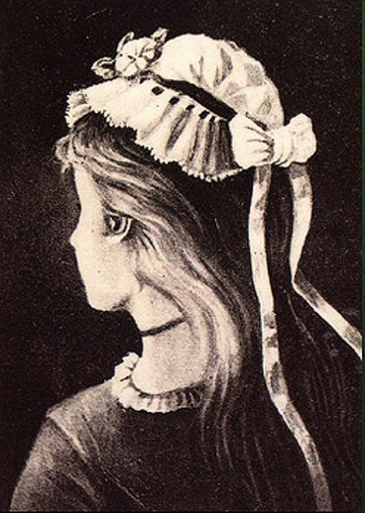

Young lady or an old woman?