Plan for a SoTL Project
by Diana Spear, Georgian College
Research Question
What are you curious about?
How to increase student participation and engagement in class activities.
What would you like to know about strategies that might hinder and/or help students to learn, in your course?
I’d like to know if I can help students’ understanding using more interactive activities.
Do you want to know if an activity, assignment, or teaching strategy “works?”
Some students have told me that everything makes sense while they are working in class, but after they go home, they have great difficulty with the material. I’d like to know if I can offer specific activities that result in better understanding in class and subsequently at home and ultimately demonstrate better understanding in their assessments.
Do you have a question about how to help your students learn a particular skill?
I would like to know if I can use a technology like Poll Everywhere to improve students’ understanding of mole calculations.

Identify challenge/outcome related to learning that is related to your question.
Describe the learning in a way that suggests how you might measure it using either qualitative or quantitative methods.
I would measure students’ understanding of mole calculations using their scores in their weekly online quiz.
I would also use data collected from surveys (e.g. using Microsoft Forms) asking students about how confident they feel tackling mole calculations.

Describe the instructional activity, assignment, or teaching strategy that will promote student learning on the outcome you identified.
SoTL projects might investigate the impact of a modification to an existing strategy or assignment. Describe how the new approach differs from the old approach and why this modification might change student learning on this outcome.
Currently, when I teach calculations, like to work through lots of examples on the board so that students have the opportunity to see the different types of questions that they may come across later in their homework or assessments. After providing examples, I ask students to try some problems on their own. Then we go through these problems together so students can see if they found the correct answer and if not, where they had difficulty. Often students struggle but are reluctant to ask for help in class or office hours.

One modification I would try would work as follows: after providing examples, asking students to try a calculation on their own, and working through that calculation on the board, I’d like to use Poll Everywhere to ask students who aren’t understanding the calculations to tell me errors they made or where they were blocked in the calculations.
My hope is that by using Poll Everywhere, students can be anonymous and more honest about where they are struggling with these calculations. If I know where students are struggling, I can help them. Also, students can learn from others’ difficulties. I can track the impact of this approach as indicated above.

Describe the evidence that would persuade an external audience that the new or modified teaching strategy improves student learning on the targeted learning outcome.
Describe the evidence you would need to collect to answer questions about the impact or value of this teaching strategy. How would you convince others that this approach is better than other approaches? What comparisons should you make? Examine students; skill before and after the assignment? Compare students who complete the learning activity to another group of students – what comparisons would be meaningful?
To show the effect of my strategy using Poll Everywhere, I would need to track the students’ scores from the online quiz on mole calculations when teaching classes without this strategy as well as classes where I implemented my strategy. Similarly, it would be useful to conduct the student survey using Microsoft Forms for both sets of students to see how confident they feel about tackling these types of calculations with and without using Poll Everywhere to address learning difficulties in mole calculations.
How and where would you publish, present, or disseminate this work?
I would probably share the results with colleagues at Georgian, in my department and our Centre for Teaching and Learning, and perhaps at our annual Focus on Teaching Conference. Depending on the response of my peers, I would consider researching a suitable venue to publish the research.
Ethical Considerations
“Respect for Persons, Concern for Welfare, and Justice” provide the foundation of Canada’s Federal Panel on Research Ethics Policy . Applying these considerations to my project, raised the following issues:
Is it unfair to teach students without using Poll Everywhere (as described above) if I expect students to achieve a better understanding of the chemistry calculations using Poll Everywhere? Could the project produce useful data without the control group ?
I believe my project demonstrates respect for students as it allows them to be anonymous in their responses when identifying difficulties with the calculations, but are there privacy concerns using the weekly online quiz results, even though the data would aggregated and not be associated with individual students?

How and where would you publish, present, or disseminate this work?
I would probably share the results with colleagues at Georgian, in my department and our Centre for Teaching and Learning, and perhaps at our annual Focus on Teaching Conference. Depending on the response of my peers, I would consider researching a suitable venue to publish the research.

Reflection
When I started this module, I was somewhat intimidated by the concept of scholarship and wasn’t sure how applicable it would be to my day-to-day teaching. What surprised me is that I have been informally following the SoTL model all along. This module showed me a more methodical and robust approach to trying and assessing my ideas.

I chose this project because I’ve noticed that many students struggle in chemistry once we move from descriptive concepts to calculations, which start with the mole. This is problematic because understanding the mole and how it works is fundamental to the remainder of the first course as well as the second course both of which are required in Pre-Health. Feedback to date indicates that students appreciate working on lots of examples in class, however, many are still struggling. I’m optimistic that using Poll Everywhere immediately after completing each question and while the challenge is still fresh in students’ minds, will help me identify where the learning blocks are so I can help understanding.

I hope that this approach also will have the benefits of students learning from their peers’ mistakes in a safe environment and also demonstrate that I care about their understanding and am available to help as needed.

Visualizing where my project will go
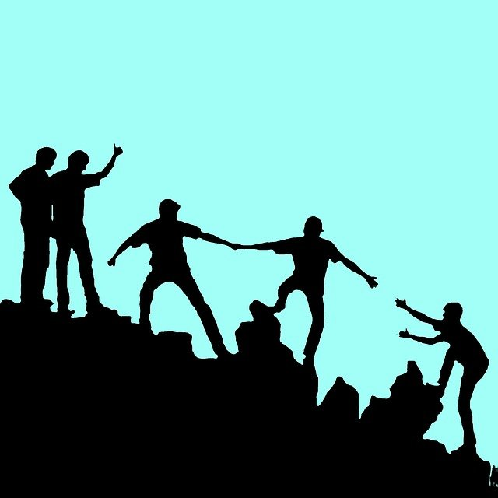
Image helping Image by mohamed Hassan from Pixabay
I chose this image of people helping each other to illustrate where my project might go for two reasons. First, I hope that this project will result in me providing more help to my students and my students helping each other to increase their understanding and problem-solving skills in chemistry. Second, if I am successful with this project, I hope that it will improve student success resulting in their acceptances into their chosen programs to enter careers in health care which are all about helping people.

Adapted from: C. J. Stanny, E. M. El-Sheikh, & H-M. Chung (2009) Getting Started with a SoTL Project
Center for University Teaching, Learning, and Assessment http://uwf.edu/cutla/

