Plan for a SoTL Project
by Elizabeth Stanley, Conestoga College
Research Question
What are you curious about?
What would you like to know about strategies that might hinder and/or help students to learn, in your course?
Do you want to know if an activity, assignment, or teaching strategy “works?”
Do you have a question about how to help your students learn a particular skill?
My students are international students and graduate engineers who are studying in a post graduate program that includes courses in Project Management and Supply Chain management. In both courses it is important that the students memorize the vocabulary used in the field to problem solve the questions that are part of the courses. The students are expected to do assigned readings during the week and memorize the vocabulary. In the first class of the course and thereafter the importance of doing the readings is emphasized. To encourage and ensure that they do the readings we have short weekly in class quizzes that are completed by each student and become part of their final grade.
The current strategy is only effective with about 50% of the students in the class. Only 50% seem to memorize the vocabulary and do well on the in-class quizzes. I am curious whether spending more time on the vocabulary in class would improve the results. If we spent time in class doing team games like a Jeopardy vocabulary game would the results improve? If we spent time in class on how to better memorize vocabulary would the result improve?

Identify challenge/outcome related to learning that is related to your question.
Describe the learning in a way that suggests how you might measure it using either qualitative or quantitative methods.
Challenge: I am an engineer and I know that in engineering school most of the students would not have to memorize vocabulary for their courses. The engineering courses have an analytical and problem-solving approach. My students may not have learned the real importance of memorization in their previous engineering courses. Unfortunately, many of them don’t figure this out until they have done poorly in 4-5 in-class quizzes. In some classes we have do makeup quizzes to improve their grades.
Outcomes: The results of trying a different approach should be improved results with most of the students. However, there is an additional difficulty. There is a lot of course material to cover in the course and class time is also spent in problem solving where the students have an opportunity to apply the skills. By spending more time in class on the vocabulary we will not have the same time to spend on the problem solving which is very important. Another concern is that we may be penalizing the 50% of the class who do take the time to do the readings at home and learn the vocabulary. They already know the vocabulary so do not need the extra class time we are spending to learn vocabulary.
Describe the instructional activity, assignment, or teaching strategy that will promote student learning on the outcome you identified.
SoTL projects might investigate the impact of a modification to an existing strategy or assignment. Describe how the new approach differs from the old approach and why this modification might change student learning on this outcome.
This term I will teach 3 sections of the same course. I would like to try 2 different approaches. The first section will continue with the existing approach where the students are expected to learn the vocabulary through the weekly readings and in-class quizzes. This section will be the control group. In the second section I will develop vocabulary games that the students in teams can play. Time is limited in the class so they will only spend 15 minutes doing these games. In the third section I will spend 15 minutes in 2-3 classes to teach them how to learn how to better memorize vocabulary. There are many skills that can be used to memorize vocabulary and I will spend time teaching them.
Upon reflection, I realized that another type of evaluation would be to interview a sample of students to determine their thoughts on whether the new approaches were effective. From an ethical point of view, I would need to reassure the students that their responses would remain anonymous. The interview results could be evaluated and provide further evidence as to whether the 2 new approaches should be implemented in the future.
Describe the evidence that would persuade an external audience that the new or modified teaching strategy improves student learning on the targeted learning outcome.
Describe the evidence you would need to collect to answer questions about the impact or value of this teaching strategy. How would you convince others that this approach is better than other approaches? What comparisons should you make? Examine students; skill before and after the assignment? Compare students who complete the learning activity to another group of students – what comparisons would be meaningful?
The evidence will be two-fold. From experience in teaching these courses I have a general idea what the in-class quiz results on average are. I will compare the averages from each section. A second comparison will need to be done. If we are spending more time on vocabulary in-class and less time on problem solving will this impact the results from the exams which are based on problem solving. I will need to compare exam results from all 3 sections to evaluate this aspect.
How and where would you publish, present, or disseminate this work?
The faculty has Microsoft Teams groups that we all participate in. I would first publish my results in these groups and solicit feedback from the other faculty members. I would also present at our staff meetings. If the results were encouraging than I would also discuss with our Teaching and Learning team who could disseminate to other faculties that are teaching courses of a technical nature.
Upon reflecting I realized that I had not really considered social media to disseminate the results. Dependent on the results from my experiment I could post on the Twitter Teaching and Learning sites or work with the Conestoga Teaching and Learning team to create a video. I could also encourage other faculty colleagues to try to modify my approach or create other approaches that might be even more effective.
Reflective Response
As an Engineer I like experiments, so I was excited about planning this one, following the guidelines provided in this Scholar module. I created an experiment that addressed the poor results that my Graduate engineers have when completing in-class quizzes on industry vocabulary. I am also interested in sharing my results with my colleagues so that we can develop even better approaches.
The image I selected below reflects my thought process as in any experiment you move forward by trying different approaches and combinations of approaches.
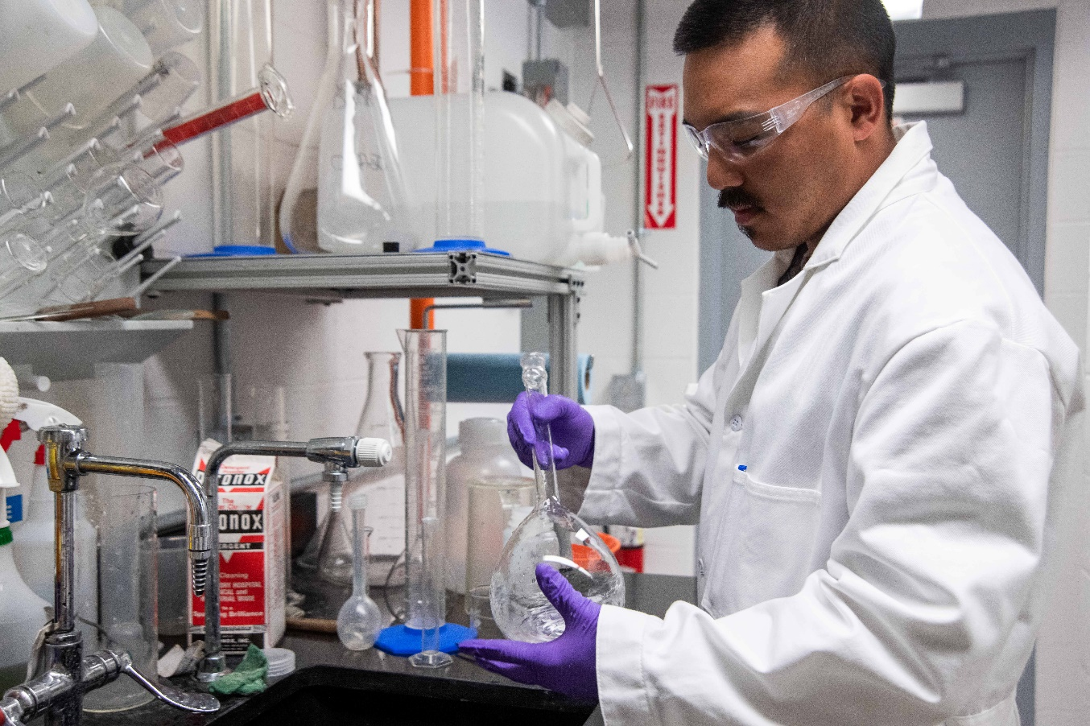
Photo by Science in HD on Unsplash

Adapted from: C. J. Stanny, E. M. El-Sheikh, & H-M. Chung (2009) Getting Started with a SoTL Project
Center for University Teaching, Learning, and Assessment http://uwf.edu/cutla/

