Empathy Map
Gather information about your learners. Consider what they think, feel, say, do, see and hear in the classroom. What do they have difficulty understanding or doing in your class? What are their collective strengths and pain points?
Hear | - Enjoy the flexibility remote learning provides: e.g., fewer scheduled synchronous sessions per week, granting more time to work on assignments and study with no commuting to in-person classes.  - Value contact with classmates via Zoom, Teams and other platforms.  - Would appreciate enhanced community engagement with classmates.
See | - Missed opportunities to practice course concepts in person, and discuss it with classmates after a lesson.  - Barrier in how classmates and the professor is contacted: no in-person visits or meetings with others.
Think | - Fear of failing due to lockdowns and current communication methods.  - Uncertainty if remote learning will decrease their chances of employment.  - Facing competing responsibilities in their school, work and personal lives.
Do | - Using course discussion boards more heavily to communicate with classmates on topics unrelated to assignments and projects.  - Reluctant to share opinions or answers in a full group setting.
Feel | - Uncertain about when they can see friends and family in person again.  - Apprehensive about the future of their selected industry of study, considering the state of the economy.
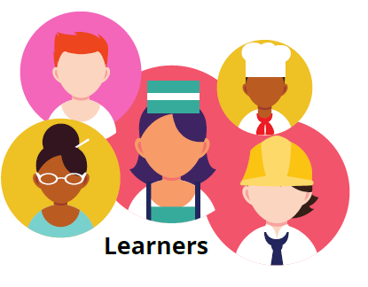

Key Strengths
Key Challenges

