CRAAP Test
Resource Title: Organizational Behaviour - Group Dynamics
Resource URL: https://ecampusontario.pressbooks.pub/orgbehavior/chapter/9-2-group-dynamics/
Currency: This resource was updated in 2017 from its original 2010 edition. The text does reflect current information on this specific topic (Tuckman's Model of Team Dynamics)
Relevance: This resource is intended for use as an open educational resource for students, primarily in Ontario. This text offers an appropriate level of complexity for the needs of my students and offers a good overview of the concepts.
Authority: The specific authors and publisher for this OER have been removed and the text has been placed under a Creative Commons license, made available through the University of Minnesota. Based on this, I would expect an appropriate scholarly focus and quality to this source.
Accuracy: This source is fully supported by a comprehensive list of references and specific information is cited appropriately. There is a clear scholarly quality to this source.
Purpose: This resource is meant to act as an educational/informational resource for students in post-secondary education. This information is presented as fact and does not contain and obvious biases.
Notes: Are there additional questions or observations you have about this material that affect your decision to use it? (i.e. this is an opinion piece that I will use to demonstrate one side of an argument).
While this resource reflects an Organizational Behaviour focus, the contents of the OER can be applied to leadership concepts as well.
Final Recommendation: Will you use this resource? Why or why not?
I will use this resource as part of an outline of the Stages of Team Development concept. This resource is supplied by a reputable publisher and offers well supported, researched, and professionally developed content. This resource also models expectations around proper citation of supporting evidence.
Padlet Screenshots below…
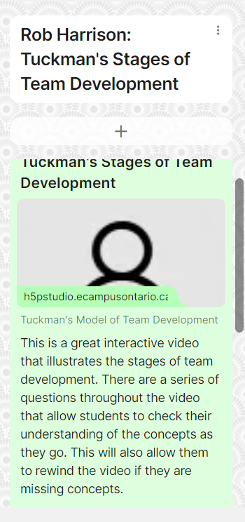 | 