Driving a Car – the Rearview Mirror

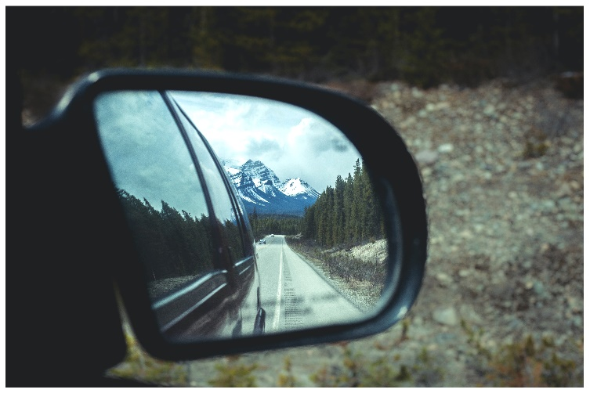Photo by Jack Hodges on Unsplash
Reflective practice is a disposition required of Early Childhood Educators
My role a Professor in this program is to provide opportunity for students to practice this skill so it becomes a disposition.
One activity I do in 2 of the courses I teach is to provide a provocation (a video, a scenario, or case study) and ask students to write, then discuss with others their thoughts again and then write or reflect again. This allows them to see the value of considering topics from multiple perspectives and how ideas, solutions can develop.

