Rob Harrison - September 22, 2021
Three characteristics of SoTL that stood out to me include:
- The importance of reflective practice in identifying questions of inquiry. This is something I have always found to be important in my practice from my first college lesson. When we focus on reflection on the outcome of student learning we are able to identify questions of inquiry that can drive our practice. For example, early in my practice, I struggled getting students engaged in the lesson and spent time researching active learning strategies that would support engagement and more meaningful interaction with the content.
- Turning research into teaching practice. This resonated with me as I recently completed my Master of Education which gave me the opportunity to dive into research on a number of topics and then apply that learning to my own practice. For example, I spent some time looking how I can embed more critical and creative thinking into my practice.
- Finally, I thought the idea of always asking a question and looking for an answer was important. This spoke to me as I saw it as a parallel to the technologist module when we are talking about empathizing with our students. The key here is to determine whether I and the students are getting what we need from each other and the course, and if not, how we can rectify that issue.

COMMENTS:

 | 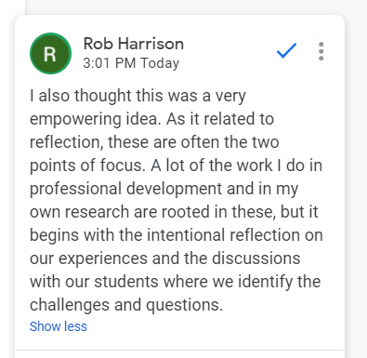

Motivations:
- Increase diversity in voice and perspective in my pedagogy
- Faculty development opportunities
- Improved outcomes and assessment scores

Comments

 | 