Misunderstood

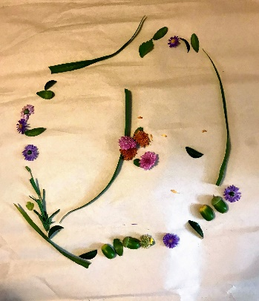Personal Photo
As a Early Childhood Educator and a Professor in the Early Childhood Education Program the notion of play and learning is often misunderstood. With the increase in international students one's own school experience also plays a role in their own past experience with play and learning. For some that is unlearning how we view teaching an learning.
Most people enter the field based on their impression of their kindergarten experience. We spend our time in the diploma program emphasizing the pedagogy of play as the child's way to learning.

