My Metaphor for Teaching and Learning
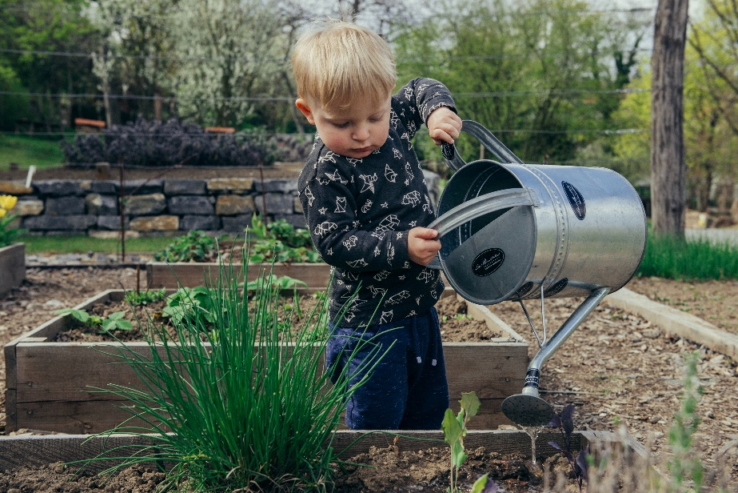 Photo by Filip Urban on Unsplashed
My Metaphor for Teaching and Learning Teaching and Learning are like Planting a Garden
Seeds are planted we water them, we weed out what is not helpful and we watch them grow!. It’s the process that matters. The Garden is the learning environment which needs some thought and attention. Sometimes after we have tended to the garden we realize we you have to start all over and rethink the seeds we plant, in order to admire the growth!
“For a seed to achieve its greatest expression, it must come completely undone. The shell cracks, its insides come out and everything changes. To someone who doesn't understand growth, it would look like complete destruction.”
― Cynthia Occelli
Retrieved from https://www.goodreads.com/quotes/1013836-for-a-seed-to-achieve-its-greatest-expression-it-must

