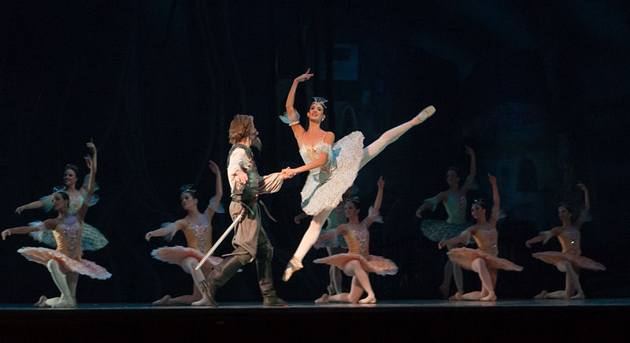
(Wilfredor, 2013, image from Wikimedia with permission)
I chose this image to represent teaching and learning within the health care field. It is an art, based on science that is interdisciplinary and counts on a team approach. For the student, past experiences are welcome; creativity, flexibility and humility is encouraged. For the teacher, contemporary classrooms based on traditional methods with openness and accountability.

