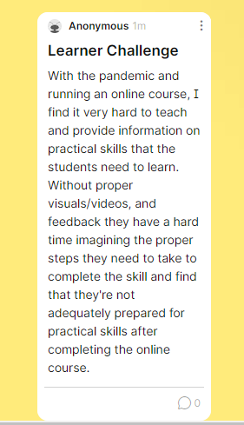

This problem stems from the feedback I received from students asking for more videos and visuals. They also really enjoyed the feedback which I think can further be improved by providing more detailed and descriptive feedback to the students for each decision they make.

Practical skills are hard to assess and test for in an online environment and students find that visuals such as videos would help them be more prepared to practice these skills in person.