V. Workman – “It’s Alive” Canva and Panopto
Context and Reasons for the Technology-Enabled Tool:
I chose Canva and Panopto as tools for students in my Career Strategies class. These tools will be used for students to develop a Personal Brand presentation, which is one of the core assessments in the course. An ongoing struggle for students is building confidence when public speaking, and this assignment will build confidence in presenting and discussing aspects of personal brand. A personal brand is both visual and auditory. Canva is a flexible and openly available tool that is great for creating a visual brand presentation. Canva is also popular in the business community and will help students develop a resume-worthy skill. By using the Canva presentation, and then recording voice narration in Panopto, this will result in a video URL that can be used for the assignment and other personal applications such as posting to a social media site.
The below screenshot is the front page of a Canva presentation I will create to explain the assignment:

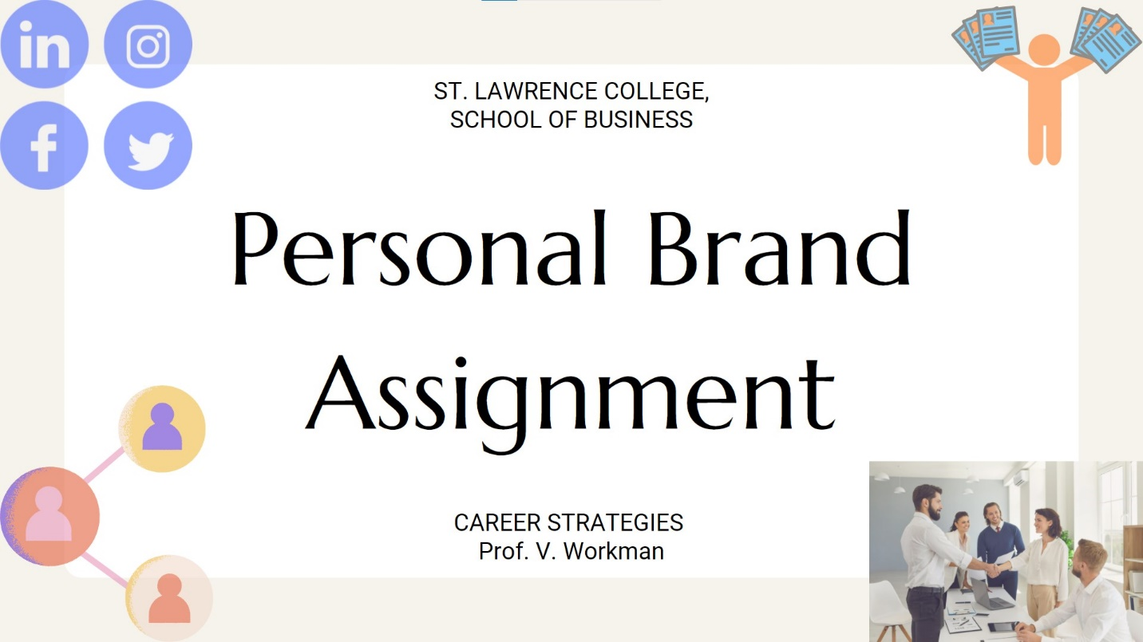

Empathy for Students and Learner Challenge:
Students have been in an “alternate delivery” model for 2 years, and speaking publicly, either in person or online has proved to be very challenging for students on many fronts. Students don’t know each other as well, feel isolated in their homes, have family and work responsibilities which do not allow them confidence in speaking online. The challenge of students not being physically together has also resulted in fewer, more natural, speaking opportunities. Many students also are not fluent with online speaking in terms of how to use tools and present themselves professionally.
Using Canva and Panopto should provide opportunities for students to present their personal brand (their professional self) in a way that uses their own photos, graphics and images as well as their own speaking voice.

Steps in Prototyping and Planned Implementation:
I used the planning template provided to work through each step of prototyping. I began with research on the tools themselves and spent time playing around with the features. I have used Panopto more frequently in the past, as it is a recording tool supported by my college. I reviewed the available tutorials and LinkedIn Learning support so I could add those as links for students who wish to learn more. Through this process, I sketched out the basics of an instructional video, using point form. I created a basic script that will be used a basis for creating the video, along with a live feed of me speaking directly to the students. This instructional video is also an exemplar of what their completed personal brand assignment could be, in terms of the use of Canva and Panopto.
The instructional video will be posted on our LMS and will walk through how to approach this activity using Canva, and then how to record using Panopto. I will also plan to include a training tutorial in Canva as a low-stakes assessment.
I have learned over time to build in synchronous experimentation time into my online classes when introducing a new tool. Students have provided feedback that they find this very helpful. Previously when I introduced a tool without this practice, I find I received many questions after class and needed to repeat myself several times. The recorded instructional video should also help this situation.
As implementation, I will model the use of Canva in other parts of the course. I will build learning and experimentation time into the weekly timetable, both individually and in break-out groups in MS Teams. I will ask for comments/questions along the way. Students complete a project reflection at the end and I will include a section on tools to gain feedback on their experience.

